CASE BOOK

DR YAHYA BIN ISMAIL

UNIVERSITI KEBANGSAAN MALAYSIA

CASE REPORT BOOK

DR YAHYA BIN ISMAIL
MBBS (MANIPAL)

CASE REPORT SUBMITTED FOR
THE DEGREE OF MASTER IN GENERAL SURGERY
NATIONAL UNIVERSITI OF MALAYSIA
2005

DISCLAIMER

This dissertation is entirely my own work except where assistance was specifically acknowledged.

Date: 1/12/2004 Dr Yahya bin Ismail

CASE NO CONTENTS PAGE

1 COLORECTAL CANCR IN YOUNG PATIENT 6-11

- MICROPAPILLARY CARCINOMA OF

THYROID. 12-18

- INTRAVESICAL MITOMYCIN IN

SUPERFICIAL BLADDER CANCER 19-27

- SUPERFICIAL TEMPORAL-MIDDLE

CEREBRAL ARTERY BYPASS SURGERY

IN RECURRENT TIA 28-34

- HEAD AND NECK

DERMATOFIBROSARCOMA OROTUBERANS 35-41

- ACUTE SCROTUM IN CHILDREN 42-51

- CHILDREN WITH LOWER GI BLEED:

MECKEL’S DIVERTICULUM 53-61

- GALL STONE ILEUS:

SURGICAL MANAGEMENT 62-69

- ACUTE INTERMITTENT PORPHYRIA
PRESENTED AS SURGICAL EMERGENCY 70-76

- SHORT BOWEL SYNDROME:

NUTRITIONAL MANAGEMENT 77-88

- CASTLEMAN’S DISEASE 89-94

- Tuberculous Liver Abscess Co-existing
with Melioidosis: A Case Report 95-102

- HEPATIC HYDATID CYSTS IN A
NON-ENDEMIC AREA IN MALAYSIA 103-112

- Delayed Presentation of
Colonic Injury after Blunt
Abdominal Trauma 113-120

- Total Thyroidectomy in
Multinodular Goitre 121-127

COLORECTAL CANCER IN YOUNG PATIENT

Abstract

A case of young gentleman with rectal carcinoma diagnosed in early 2002 is presented. A brief literature review of this condition follows. Behavioural patterns, prognosis as well as distribution of incidence are discussed here.

Key words: Colorectal cancer (CRC), mucinous adenocarcinoma.

Introduction

Colorectal cancer (CRC) is predominantly disease of elderly, but it is not absolutely

restricted to this population. In US and European literature, incidence of CRC in

subjects age 40 or younger is between 2 to 8 percent (1-3). The outcome is

generally poor as compared with older patients due to late presentation and more

aggressive disease (2) .Detection of CRC in young patient should be no different from

that in old patient but demand high index of suspicion.

Case History

A 40 year old Malay male first presented to hospital with symptoms of Lower Gastro

Intestinal Bleeding on 25th February 2002. Going back to history the patient had history

of passing blood mixed with stool several times for the period of last six months. There

were no symptoms suggestive of intestinal obstruction. Patient is a known case of

Diabetes Mellitus, on Oral Hypoglycemic drugs for the past 5 years .He works as

a farmer and come from low socio economic group. No family history of CRC. On

examination there was a circumferential growth measured approximately 4 cm from the

ano-rectal junction. CEA(Carcino embryonic antigen) was normal. Subsequently biopsies

was taken and the Histopathological report showed Adenocarcinoma. CT scan abdomen was arranged before the operation and there are increase in perirectal fat and enlarged lymph nodes overlying the sacrum. Liver was normal.. Following that, Ultra low and double stapling technique anterior resection with covering ileostomy was performed on 5th of March 2002. However, intraoperatively 2 small liver nodules felt. Post operatively patient recovered well and closure of ileostomy was done on 23rd of June 2002. In view of his young age at presentation, screening colonoscopy was planned for the 1st degree relative. Surveillance Ultrasound Liver and CT scan was arranged for him to confirm the presence of liver metastasis.

Discussion

The incidence of CRC in patients less than 40 years old is estimated to be 2% to 8% in

United States and Europe,(1-3) and about 1.3 million cases per million children occur in

Japan. A study done by Liang et al(4) from Taipei showed tumour have been evenly

distributed throughout the colon for young patient less than age of 20 years old.. (7-9)

They also showed a similar pattern except for the higher rate of synchronous lesions.

Adenocarcinoma was the major pathologic diagnosis majority of CRC but the reported

percentage of mucinous carcinoma has ranged from 22% to 43% of cases in young

patient with CRC (9,15).The most common presenting symptoms in the study done by

J.Brant et al (5) were abdominal pain, blood per rectum, changes in bowel habits and

weight loss.The findings were similar to the study done by Liang et al(4) but there was

higher incidence of abdominal fullness and even intestinal obstruction(4) . Polissar et al

reported that the presence of a single symptom was not a negative prognostic indicator of

survival, whereas the presence of multiple symptoms were a prognostic indicator. He and

others also foun that the duration of symptoms before presentation up to one year did not

altersurvival in his series. Another study showed that the most common presenting

symptom, regardless of tumour location was abdominal pain. This is followed in

frequency by weight loss, blood per rectum, nausea vomiting, constipation, and narrow

caliber stools(6). Prognosis in CRC in the youngpatient is usually poor. (8) The 5 year

survival has been reported in Taiwan as 21.4 percent(4),which is similar to others ranging

from 10-29 percent. Some studies showed that poor prognosis is due to more advanced

tumour and high incidence of mucinous adenocarcinoma. (4) The same study also

showed that high incidence of synchronous lesion identified in young patient.

Epidemiologic data suggest that some genetic factor might play a role in the

carcinogenesis of CRC in young patient in China,(10) but no conclusive pattern has been

confirmed. (11)Most families with HNPCC(Hereditary nonpolyposis colorectal cancer)

carry the germline mutation of one of four genes—hMSH2, hMLH1, hPMS1, hPMS2.

These genes are involved in the DNA mismatch repair.(12)In an appreciable propotion of

cases of early onset CRC that did not fulfill the Amsterdam criteria, the patients were

found to carry mismatch repair gene mutations.(17) Farrrington et al suggested that it is

necessary to analyze DNA mismatch repair genes regardless of family history, especially

in early onset CRC. The mutations of DNA mismatch repair genes provide a possible and

reasonable explanation for CRC in young patients. Inconclusion the pattern of CRC in

young patient somehow slightly differ from elderly . This includes the behavior,

distribution as well as the prognosis. Surgeons should be aware of the possibility and the

ambigious clinical behaviour of such early onset of CRC and should arrange colonoscopy

or barium enema examination if indicated.

References

- Pitluk H, Poticha SM: Carcinoma of colon and rectum in patients less tha 40 years of age. Surg Gynecol Obstet 1991;172:1-7
- Jarvinen HJ, Turunen MJ: Colorectal carcinoma before 40 years of age: prognosis and predisposing conditions. Scand J Gastroenterol 1984; 19:634-638
- Safford KL, Spebar MJ, Rosenthal D: Review of CRC in patient under age 40 years. Am J Surg 1981; 1981 142:767-769.
- Liang-Kung Chen et al :Colorectal cancer in Patients 20 Years Old or Less in Taiwan;www.medscape.com.
- J. Brant Paramore, John P, Karen A. Colorectal cance in patients under 40: Presentation and Outcome. The American Surgeon June 1998;64:563-67
- Hall A, Coffey RJ. Cancer of large bowel in young. AM J Surg 1961;102;66-72
- Yamamoto K, Tanaka T et al: Carcinoma colon in children: case report and review of Japanese literature.J Gastroenterol 1994; 29:647-652
- Minardi AJ Jr,Sittig KM et al:Colorectal cancer in young patient. Am Surg 1998;64:849-853
- Lee PY, Fletcher WS, Sullivan ES, et al: CRC in young patients : characteristics and outcome. Am surg 1994; 60:607-612
- Yang G: Comparison between large bowel cancer in middle aged and old people. Chin J Epidemiol 1993; 14;341-345
- Shahrudin MD, Noori SM: Cancer of the colon and rectum in the first three decades of life. Hepatogastroenterology 1997; 44:441-444
- Dunlop MG, Farrington SM, et al: Cancr rik associated with germline DNA mismatch repair gene mutations. Hum Mol Genet 1997; 6:105-110
- Farringon SM, et al: Systemic analysis of hSMH2 and hMLH1 in young colorectal cancer patient: Am J Hum Genet 1998; 63:149-759

PAPILLARY MICROCARCINOMA OF THYROID.

Abstract

Papillary microcarcinoma are a specific subgroup of papillary thyroid cancer. Histologically it is similar as papillary thyroid carcinoma but are 1.0cm or less in diameter. Generally this tumourdare commonly found during autopsy and in thyroid glands excised for other pathology. This tumour can metastasize to regional lymph nodes but its ability to cause significant morbidity and mortality has been questioned. It represent nearly 30 per cent of all papillary cancers, hence they are an important group.A case of young woman with micropapillary carcinoma of thyroid is presented. A brief literature review of conditions follows.

Key words: Papillary microcarcinoma (PMC) , lobectomy, prognostic scoring

Introduction

Thyroid cancer represents 1 per cent of all malignancies and was responsible for only 348 deaths in England and Wales in 1991 ¹. However it is the most common endocrine malignancy. Papillary thyroid carcinoma accounts about 80 per cent of cases .Papillary carcinoma of thyroid may be discovered incidentally during routine histological section and small foci are also frequently found during autopsy ⁽²⁾ Prolonged follow-up of patients with papillary tumour of small size has shown that the prognosis is very good ⁽³⁾ Papillary thyroid cancer is defined as a malignant epithelial tumour showing evidence of follicular cell differentiation, typically with papillary and follicular structures as well as characteristic nuclear changes (ground glass, large size, irregular and pseudoinclusion) .Papillary thyroid carcinoma is typically invasive but can be circumscribed or encapsulated. Calcifed structures, psammoma bodies are found in the stroma in approximately 50 per cent of cases. PMCs are generally well differentiated. They exhibit characteristic cytological features of papillary lesions. In recent years further subdivision of PMCs has been proposed ⁽¹⁾. The term ‘tiny’ refer to 5-10mm foci, and ‘minute’ for foci less than 5mm diameter.

Case History

A 41 year old Indian female first presented to hospital with history of anterior neck swelling for 5 years duration. The swelling is insidious in onset and not associated with pain, dysphagia, dyspnea or any toxic symptoms. There were no symptoms suggestive of hypothyroidism. She’s married with 5 children. On examination, there were a swelling measured about 5 x4cm in the midline of the neck, lobulated, non tender,firm in consistency and move up with swallowing. FNAC showed nodular hyperplasia. Vocal cord assesment were normal. Thyroid Function test was done and the results within normal limit. Subsequently, patient underwent Right Subtotal thyroidectomy and Left Lobectomy. Histopathological Examination (HPE) reported the findings as Right gland nodular hyperplasia and left lobe papillary microcarcinoma. Post operatively patient developed hypothyroidism and was supplemented with L-Thyroxine 0.2mg daily. Serum calcium was normal. Patient is currently under regular 6monthly follow-up in surgical clinic with life long Thyroxine .

Discussion

Geographically the prevalence of PMC is so varied. Fukunaga an Yatani ⁽⁵⁾, demonstrated a significantly higher prevalence of PMC in Japan (28.4 per cent), than in Canada (6.0 per cent), Poland (9.0 per cent). Interestingly the high prevalence was maintained in first and second generation Japanese living in Hawaii (24.2 per cent). High intake of Iodine is associated with a rise in the prevalence of PMC in Japan compare to low rates in the goitrous areas of Chile (2). In majority of autopsy studies ^{(1,6)} no significant difference in the prevalence rate of PMC demonstrated between sexes. In Portugal the prevalence of PMC was significantly higher in older age group (mean age 61.4 years) . Cervical lymph node metastases from PMC have been shown in 4.3 per cent of cases in Japan and 3.1 per cent in Sweden ¹. In most cases the lymph node involvement was on the same side as thyroid focus, but nodes have been demonstrated bilaterally and even on the opposite side of primary focus
The treatment of differentiated papillary thyroid cancer has been hotly debated down over the years for a conservative lobectomy and those for aggressive total thyroidectomy Although many series ⁽⁴⁻⁶⁾ have shown that the presence of cervical node metastases at presentation increases the risk of further nodal recurrence, it does not increase mortality⁷. The main argument for total thyroidectomy approach is increase incidence of complications where the operation is associated. Incidence of recurrent laryngeal nerve injury of 0.7-0.9 per cent ⁷ similar for both procedures, that of permanent hypocalcemia, due to damage to parathyroid gland varies substantially.To guide for surgical therapy for papillary thyroid carcinoma a number of prognostic scoring systems have been deployed. Using AGES based on Age at presentation, Grade,Extent and Size of primary. Patients were grouped into minimal risk (AGES less than 4) and high risk if (AGES score 4 or more). Lobectomy or isthmectomy are appropriate in low risk group, but ipsilateral lobectomy with contralateral subtotal lobectomy was superior to high risk group. However based on this scoring system, local recurrence was significantly higher in lobectomy group.The AGES than simplified by Lahey Clinic to AMES in which M is metastases. High risk group features patient more than 40 years in men and over 50 years in female, distant metastases and size greater than 5 cm. MACIS is the latest scoring system, which uses Metastases, Age, Comlpleteness, Invasion and Size (9).Unfortunately this score can be used only after primary operation.
The most recent data from the Mayo Clinic suggest that ipsilateral lobectomy and contralateral subtotal lobectomy, leaving a 1-2-g remnant, combined with simple excision of involved nodes, is the approach of choice, with no benefit being gained from total thyroidectomy. While some agree with this ¹ others have shown that radical surgery does not influence recurrence and recommend lobectomy and isthmectomy ⁶ With respect to adjuvant therapy the consensus appears to be the routine use of thryoxine to suppress TSH, but not the use of radioiodine as there is no difference in the recurrence rate.
The most recent data from the Lahey Clinic ⁸ based on the AMES prognostic scoring system, split patients with PMC into two groups: women aged 50 years or younger and men of 40 years or less (low risk), and the older age groups (high risk). The recommendations for the low-risk group are conservative thyroid surgery, modified or limited node dissection and thyroid suppression. The recommendations for the high-risk group are bilateral thyroid surgery, modified or limited node dissection, thyroid suppression and radioactive iodine [10]. It is difficult to group all PMCs together and recommend one approach based solely on size as there are many varied presentations of this disease. It is, however, an absolute requirement that the treatment of PMC should not cause more morbidity than the disease process itself. To this end, it is my belief that the care of patients with thyroid cancer, if total thyroidectomy is to be achieved with an acceptable level of morbidity, should not be undertaken by the occasional thyroid surgeon. Taking into account all opinions expressed in the published literature, the following therapeutic recommendations are offered
1 Neck nodal metastases (papillary thyroid cancer confirmed by FNAC or biopsy) and no primary lesion identified. Total or near-total thyroidectomy, `node picking' and TSH suppression, await pathology findings. If PMC excised completely, regular follow-up only.
2 Neck nodal metastases and site of PMC known before operation. Ipsilateral lobectomy and contralateral subtotal (or total) lobectomy, `node picking' and TSH suppression. If the paratracheal nodes are involved they should be excised. If PMC excised completely, regular follow-up only.
3 PMC known before operation and no nodes in a patient aged 39 years or less. Ipsilateral lobectomy and isthmectomy, with intraoperative palpation of the opposite lobe and subtotal excision if abnormal, and TSH suppression. If PMC excised completely, regular follow-up only.
4 PMC known before operation and no nodes in a patient aged 40 years or more. Ipsilateral lobectomy and contralateral subtotal lobectomy, and TSH suppression. If PMC excised completely, regular follow-up only.
5 Incidentally discovered PMC in thyroid excised for other pathology. If the patient is low risk for age and the tumour is excised completely with no nodes, regular follow-up is advised, although this is of questionable value. If high-risk age group, incomplete incision, nodal metastasis in retrospect or DNA aneuploid tumour (if available), give TSH suppression. Offer further treatment, re-exploration or radioiodine after discussing prognosis with patient.
6 Occasionally multifocal PMC will be identified either as a dominant lesion with other foci or multiple foci. The biological significance of multifocal lesions is unclear and there is no clear recommendation for treatment. The approach to such patients is likely to reflect the treatment philosophy of the individual surgeon.
7 A further issue is what to tell the patient with an incidentally discovered PMC. Only Frauenhoffer et al. [11] have commented on this, suggesting that carcinoma should not be mentioned in younger patients who have a completely excised PMC. They added that the `benign' behaviour of these tumours may not warrant the potential social and economic complications of a `cancer' diagnosis. This approach may be unacceptable to some practitioners; it is an issue for the individual surgeon to decide on.
In summary, PMC of the thyroid is not uncommon and is associated with a good or excellent prognosis. The nature of surgical therapy should depend on the clinical presentation, and must be achieved with minimal morbidity to the laryngeal nerves and parathyroid glands.

Referrences:
- Branley, M.D; Harrison, B.J. Surg Dec 1996; (1674-1683). Papillary carcinoma of Thyroid (review).
- Sampson RJ, Key CR, Buncher CR, et al. Thyroid carcinoma in Hiroshima and Nagasaki. Prevalence of thyroid carcinoma at autopsy. JAMA 1069; 209: 65-70
- Woolner LB Lemmon ML, Beahrs OH, Black BM, Keating FR. Occult papillary carcinoma of thyroid gland; a study of 140 cases observed in a 30 year period. J Clin Endocrinol 1960; 20: 89-105.
- Sampson RJ, Key CR, Butcher CR, Metastases from occult thyroid carcinoma, and autopsy study from Hiroshima and Nagasaki. Cancer 1970: 803-11.
- Fukunaga FH Yatani R. Geographic of pathology of occult thyroid carcinomas. Cancer 1975; 36: 1095-9.
- Bondeson L, Lunjberg O. Occult thyroid carcinoma in Malmo, Sweden. Cancer 1981; 47: 319-23.
- Hay ID, Grant CS, Taylor WF. Ipsilateral lobectomy versus bilateral lobar resection in papillary thyroid carcinoma. Surgery 1987; 102: 1088-95.
- Grant CS, Hay ID, Gough IR et al. Local resection in PMC: is extent of surgical resection is important? Surgery 1988; 104: 954-62.

Intravesical Chemotherapy therapy following TURBT in Bladder Cancer.

Abstract:

Transitional cell carcinoma is the most common form of Urinary bladder carcinoma. The management emphasize on the stages of diseases. We report a case of Ca Bladder occurring in a 73 year old Chinese lady who was managed by combination of surgery and intravesical chemotherapy. The combination therapy in her case is one of the options adopted by our department regarding management of Superficial Bladder cancer.

Keyword: Intravesical Mitomycin, Superficial Bladder cancer.

Introduction:

Bladder cancer is a malignant neoplasm originating from the surface lining of the bladder. The most common form is transitional cell carcinoma (TCC) which accounts for 90-95% of all bladder cancers. The remainder are squamous cell carcinomas (3-7%), adenocarcinomas (1-2%) and rare neuroendocrine, small cell and signet cell carcinomas (<1%). When the cancer is confined to the mucosa or submucosa of the bladder it is referred to as "superficial," primarily defined by its accessibility to local surgical cystoscopic removal rather than its intrinsic invasive potential.
Approximately 70% to 80% of patients with newly diagnosed bladder cancer will present with superficial bladder tumors (i.e., stage Ta, CIS, or T1). Those who do present with superficial, noninvasive bladder cancer are often curable, and those with deeply invasive disease can sometimes be cured by surgery, irradiation, or a combination of modalities that include chemotherapy. Studies have demonstrated that some patients with distant metastases have achieved long-term complete response following treatment with combination chemotherapy regimens. There are clinical trials suitable for patients with all stages of bladder cancer; whenever possible, patients should be included in clinical trials designed to improve on standard therapy.
The major prognostic factors in carcinoma of the bladder are the depth of invasion into the bladder wall and the degree of differentiation of the tumor. Most superficial tumors are well differentiated. Patients in whom superficial tumors are less differentiated, large, multiple, or associated with carcinoma in situ (CIS) in other areas of the bladder mucosa are at greatest risk for recurrence and the development of invasive cancer. Such patients may be considered to have the entire urothelial surface at risk for the development of cancer.
Adverse prognostic features associated with a greater risk of disease progression include the presence of multiple aneuploid cell lines, nuclear p53 overexpression, and expression of the Lewis-x blood group antigen ¹. Patients with CIS who have a complete response to bacillus Calmette-Guerin have approximately a 20% risk of disease progression at 5 years; patients with incomplete response have approximately a 95% risk of disease progression ¹. Several treatment methods (i.e., transurethral surgery, intravesical medications, and cystectomy) have been used in the management of patients with superficial tumors, and each method can be associated with 5-year survival in 55% to 80% of patients treated ^{1,2}.

The following illustration shows the relationship between the location and depth of the tumor and the stage.
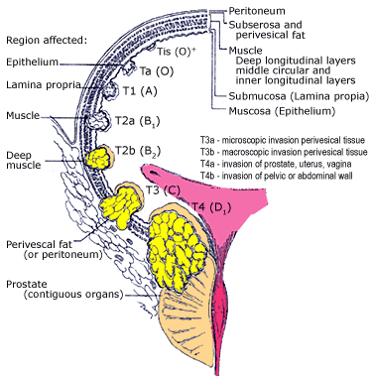
Figure adapted from Smith's General Urology, 15th ed, EA Tanago & JW McAninch eds, Chapter 2: Urothelial carcinoma: cancers of the bladder, ureter and renal pelvis, P Carroll (au). McGraw-Hill Co., NY, 2000.

Case History:
L.K.N is a 71 years old Chinese lady was first presented with history of painless hematuria, reduced in appetite and weight loss for 1 month duration. Following that an Ultrasound was done and showed an irregular mass situated on the left posterolateral wall of the bladder. Subsequently IVU done on the following day showed filling defect on the same location.
She was than subjected for cystoscopy and findings suggestive of bladder tumour. TURBT was carried out and has to be abandoned after about 80% of tumour resected because of bleeding excessively. Immediately after operation a first dose of Intravesical Mitomycin 40mg was given and continuously given weekly for 6 cycles. Patient showed rapid recovery following surgery and no reported adverse effects of mitomycin.
Nine week after first TURBT, another cystoscopy was performed on her . At the same sitting completion of TURBT done. It was also noted that the remnants of tumor was getting smaller and less vascular. No complications during second surgery. She was doing well postoperatively and still undergo regular follow up here.

DISCUSSION:

The overall goals are to remove all visible tumor whenever possible, reduce recurrences, and prevent disease progression. For visible tumorous lesions of the bladder, the first line of treatment is endoscopic removal through the cystoscope in a procedure commonly referred to as TURB or TURBT (Trans Urethral Resection of Bladder Tumor). The goals of such a procedure are to obtain adequate tissue for pathologic examination and complete obliteration of all visible tumors either by resection or fulguration.
CIS is not amenable to surgery due to its diffuse surface spreading property. Unfortunately, even for visible tumors, the aggregate chance of disease recurrence approximates 60% by 5 years and 80% by 10 years after surgery alone ³. Evidence exists implicating several factors responsible for this high recurrence rate including failure to completely remove the primary tumor, tumor cell reimplantation during resection, the microscopic extant of disease already present, and emergence of second primaries due to a generalized carcinogenic "field defect" in the urothelium. For these reasons, adjuvant medical treatment in the form of intravesical drug therapy is commonly used for those tumors assessed to be at higher risk for recurrence and/or progression.
The ability to render a patient free from disease over time remains the single most important consideration in selecting the appropriate intravesical agent. In general, intravesical agents have 3 major indications:
- Prophylaxis for recurrence after all tumor has been surgically removed
- Ablation of residual measurable tumor
- Primary therapy for carcinoma in situ (CIS)
Of course, macroscopic removal of all visible tumor may still leave microscopic foci of viable tumor that requires the ablative effects of the agent. In addition, patients with mixed CIS and papillary disease depend on both ablative and prophylactic properties. Nonetheless, these categories form a convenient basis to compare the efficacy results of different agents. An even more important further consideration is the ability of these agents to prevent disease progression and ultimately improve patient survival.
Ideally, when used for tumor prophylaxis, intravesical therapy should result in the complete elimination of tumor recurrence over that patient's lifetime. However, even extending freedom from disease for several years can be a tangible benefit to the patient in terms of decreasing anesthesia-dependent operations, and office procedures and psychological distress.
What is much less clear is whether altering the recurrence rate or number of tumors per recurrence alone is worthwhile especially if uncertainty continues to mandate frequent cystoscopies and ultimate progression is not altered. The situation with ablative therapy for either visible tumor or CIS is more straightforward. Generally only a complete response, i.e., total cancer elimination with negative cytology, is clinically significant although conversion of an aggressive subtype such as stage T1 grade 3 to a nonaggressive subtype (stage Ta grade 1-2) may have some practical meaning. All forms of ablative intravesical therapy work best when tumor burden is minimal.
There are two general types of intravesical therapy commonly employed for the treatment of superficial bladder cancer: chemotherapy and immunotherapy. Both are commonly administered 2-3 weeks post TURBT using an induction cycle of one treatment per week X 6 weeks, a two hour retention time and variable "maintenance" cycles thereafter. The inherent toxicity of the intravesical agent must also be carefully weighed in selecting and applying topical therapy. Most but not all agents cause a self-limiting cystitis that is usually transient but occasionally persists for weeks-months and rarely even leads to a functionally contracted low capacity bladder.
After over 30 years of empiric testing, only 3 chemotherapeutic agents given as solo agents have demonstrated acceptable efficacy and toxicity via the intravesical route: thiotepa (and a related alkylating agent used in Europe, ethoglucid), adriamycin (and it's derivatives epirubicin and valrubicin), and mitomycin. Multiple randomized trials comparing these chemotherapeutic agents to TURBT alone have revealed a net reduction in tumor recurrence of 12-15% (i.e., 60% recurrence with TURBT vs. 45% with TURBT plus chemotherapy) with no clear superiority of one agent over another ⁴.
In an ablative capacity, these agents will induce complete responses of small volume tumors (< 2 cms) and CIS in 30-50% of cases. The median duration of complete response (CR) varies between 6 months for adriamycin vs. close to 2 years for mitomycin⁵. All the chemotherapeutic agents cause some degree of irritative cystitis that is generally well tolerated but occasionally results in drug withdrawal. Unique toxicities include myelosuppression by thiotepa due to systemic absorption, hypersensitivity by adriamycin, and a palmer and genital skin rash with mitomycin.
Recently it has been appreciated that one single dose of any of the chemotherapeutic agents given immediately after the completion of TURBT may be just as effective as a traditional 6 week delayed induction course with attendant decrease in toxicity ⁶. This benefit is reduced even after a delay of 24 hours, suggesting it works primarily to reduce tumor cell reimplantation.
In the therapeutic setting, many intravesical chemotherapeutic agents have demonstrated ablative activity. Thiotepa induces complete responses averaging between 30-40%, works best against smaller tumors, and is least effective against tumors in patients that have already recurred after prior thiotepa treatment. Adriamycin may be slightly more active than Thiotepa, appears to be more effective for recurrent tumors than primary tumors, is equally effective on low and high grade tumors, and works against prior Thiotepa failures. Interestingly, Epirubicin, a derivative of Adriamycin, was reported to be more effective against primary and chemotherapy naive tumors. ^{4,5}Complete response rates with Mitomycin have generally been higher than the other agents, averaging ~50%, with even higher responses reported in marker lesion studies. Only a few studies have examined the utility of routine up-front chemoablation with Mitomycin prior to an inspection cystoscopy with optional TURBT.

Conclussion:
The utility of extended treatment with chemotherapy remains controversial. While many clinical studies have employed this strategy, few have actually investigated whether this approach is helpful. From a theoretical standpoint, once surgical and chemotherapeutic ablation is achieved, the addition of further toxic therapy should be unnecessary. While the goal should be to surgically ablate all visible disease, this is not always possible due to tumor location, tumor diffuseness, and underlying patient co-morbidity.

Refferences:
- Hudson MA, Herr HW: Carcinoma in situ of the bladder. Journal of Urology 153(3, Part 1): 564-572, 1995.
- Torti FM, Lum BL: The biology and treatment of superficial bladder cancer. Journal of Clinical Oncology 2(5): 505-531, 1984.
- Utz DC and Farrow GM. Management of carcinoma-in-situ of the bladder: the case for surgical management, Urol. Clin. North Amer. 7: 533-41, 1980.
- Traynelis CL and Lamm DL. Current status of intravesical therapy for bladder cancer. S. N. Rous (ed.) Urology Annual, Vol. 8, pp. 113-143. New York: WW Norton and Co, 1994.
- Solsona E, Iborra I, Ricos JV, Monros JL, Casanova J and Dumont R. Effectiveness of a single immediate mitomycin C instillation in patients with low risk superficial bladder cancer: short and long- term followup, J Urol. 161: 1120-3, 1999.
- Witjes JA, Caris CT, Mungan NA, et al.: Results of a randomized phase III trial of sequential intravesical therapy with mitomycin C and bacillus Calmette-Guerin versus mitomycin C alone in patients with superficial bladder cancer. Journal of Urology 160(5): 1668-1672, 1998.

SUPERFICIAL TEMPORAL(STA)-MIDDDLE CEREBRAL ARTERY(MCA) BY-PASS SURGERY IN TREATMENT OF RECURRENT TRANSIENT ISCHAEMIC ATTACK (TIA).

Abstract:

The used of anti-coagulant for the medical therapy in the management of TIA has been recommended and still being used for the prevention of the cerebral infarct as result of impairment in cerebral circulation. But for the symptomatic recurrent attack of TIA, a few surgical options including Extracranial-Intracranial Bypass surgery has been tried. A case of recurrent attack of TIA treated with STA-MCA by-pass surgery is reported here for the stenosed intracranial Left Internal Carotid artery after failure of medical therapy.

Key word: TIA, EC-IC bypass surgery.

Introduction:
The purpose of extracranial to intracranial(EC-IC) bypass is to augment cerebral blood flow. This procedure entails connection of the superficial temporal artery (STA), or a venous conduit, to a branch of the middle cerebral artery (MCA). Fur the past 35 years this method has been available as a potential treatment of stroke or TIA. This procedure has been touted as a great technical achievement, and at other times a therapeutic failure.

Yasarghil, in Zurich, Switzerland, in 1967 was the man who first performed the EC-IC bypass surgery ¹. In 1977 an International, randomized, prospective study was instituted to assess the safety and efficacy of the procedure . As a results of negative outcome of the International bypass study published in 1985 ,² a dramatic reduction in the number of the bypass procedures were observed, and to some degree redirected the thinking of physicians involved in the treatment of stroke.

The surgical options available for treatment of stroke are limited. Carotid endarterectomy has been proven in large, randomized trials to be an effective treatment in selective patients with asymptomatic or symptomatic extracranial carotid artery stenosis of at least 60% or 70%, respectively ³.For intracranial arteries endarterectomy has not met with much success, mainly due to difficulty in establishing a satisfactory distal intimal breakpoint. Intracranial artery transposition, most commonly anastomosing the superior cerebellar and posterior cerebral arteries in a side-to-side fashion, is rarely indicated, rarely performed and technically quite challenging. MCA embolectomy held brief popularity but has been essentially replaced by endovascular techniques. EC-IC bypass however has continue to evolve. As our understanding of etiology of stroke has increased, so has our ability to select patients for EC-IC bypass. Additionally, advances in surgical technique and neuroanesthesia have increased the bypass options and decreased the morbidity of the procedure.

For most of the EC-IC bypass previously done elsewhere, the outcome to determine whether anastomosis of STA-MCA could reduce stoke and stroke related death among symptomatic patients are important, especially in inaccessible atherosclerotic stenosis or occlusion of the internal carotid or MCA.

Case history:

S.F is a 57 year old, malay man with a history of weakness on his right side of the body associate with right hand incoordination and expressive aphasia which is lasted about 10 minutes for the past 6 month. He was seen and treated with aspirin by a physician for Transient Ischaemic attack.. However the symptoms worsen for the past 3 months , where he had 20 attacks of similar symptoms during that period. He was admitted , CT and MRI done showed small area of infarct in Left basal ganglia. During his stay, he was started on warfarin anticoagulant. Work-up for hypercoagulable state and cardiac disease was negative. Subsequently cerebral angiogram revealed high grade left MCA stenosis with incidental finding of small right anterior cerebral artery aneurysm. In spite of on anticoagulant his neurological symptoms remains fluctuating. After extensive discussion, it was elected to proceed with EC-IC bypass surgery using Superficial temporal to Middle cerebral arteries. Post-operatively he has done well with no further ischaemic symptoms during his first 2 months follow-up. A repeat angiogram was arranged 30 days after surgery and demonstrates the patency of the anastomosis, the degree of retrograde flow in the MCA, and the number of branches of MCA filled. This case demonstrates a patient with persistent symptoms of cerebral hypoperfusion, despite maximal medical therapy, who benefited from EC-IC bypass.

Discussions:

A results of EC-IC bypass study group done in 1985 on 1495 patients demonstrates that STA-MCA bypass did not reduce subsequent events compared to best medical therapy in the patients studied². Perhaps the most important issue consideration of EC-IC bypass in patients with stroke is the mechanism of stroke.²This trial may have failed to prove the benefit of surgery because many patients in the trial may suffer embolic strokes. Also, patients with ICA occlusion and persistent symptoms who fared worse after surgery were likely having recurrent emboli from the occluded ICA stump.
Advances in surgical technique have greatly expanded the options available for performing an EC-IC bypass. Despite the negative results of the EC-IC bypass study ³, most cerebrovascular neurologists and neurosurgeons believe there is a subgroup of patients that will benefit from revascularization surgery in the form of a bypass. ⁴ A study done by Grubb et al in 1998 give the best evidence to date indicates that patient with impaired angiographic collaterals, watershed stroke on pre-operative imaging, radionuclide imaging evidence for impaired CBF, and those who have failed optimal medical therapy are the best candidates for EC-IC bypass. He also demonstrated in the same trials that patient with an occluded ICA and ipsilateral increased oxygen extraction fraction by PET scanning have a significantly increased risk of future stroke. Unfortunately, PET is not widely available.

⁵Another trial conducted by Japanese neurosurgeon in 1992, Ishikawa et al demonstrates in 63 patients with internal carotid artery occlusion manifesting as TIA received STA-MCA bypass surgery and medical treatment only. The outcome was no significant different but positron emission tomography studies suggested that patients with misery perfusion in the chronic stage benefited from EC-IC bypass surgery.

Inconclusion, we feel EC –IC bypass has a definite role in treatment of TIA in carefully selected patients fulfilling strict criteria as above. With improvement in the screening method ( via eliminating embolic etiology), improves in the measures of regional CBF to direct the anastomosis, improved method to predict the hemodynamic effects of bypass, and improved surgical techniques, the role of EC-IC bypass surgery is expected to become more clearee in the near future..

References:

- Yasargil MG,ed. Anastomosis between the superficial temporal artery and a branch of the middle cerebral artery. In microsurgery applied to neuro-surgery. Stuttgart: George Thime, 1969,pp 105-15.

- The EC-IC bypass study group. The international cooporative study of extracranial/intracranial artery anastomosis: Methodology and entry characteristics. Stroke. 1985; 16:397-406.

- North American symptomatic carotid endarterectomy trial collaborators. Beneficial effect of carotid endarterectomy in symptomatic patients with high grade carotid . N Engl J Med.1991;325:445-453.

- Grubb RL Jr, Derdeyn CP, Fritsch SM, et al. Importance of hemodynamic factors in the prognosis of symptomatic carotid occlusion. JAMA.1998; 280:10555-1060.

- Ishikawa T, Yasui N, Suzuki A, Hadeishi H, Shishido F. Uemura K,Dept of surgical Neurology, research Institute for Brain and Blood Vessels –Akita. Neurologia Medico-Chirurgica. 32(1);5-9,1992 Jan.

HEAD AND NECK DERMATOFIBROSARCOMA PROTUBERANS(DFSP) .

ABSTRACT:

Dermatofibrosarcoma protuberans(DFSP), is a low grade sarcoma, presents as an asymptomatic indurated cutaneous nodules in early to middle age adult life. The seemingly benign appearance of this tumour can be misleading to patient and physicians alike. Treatment frequently delayed and all to often inadequate. Resection with conservative margins has led to unacceptable local tumor control. A case of recurrent dermatofibrosarcoma protuberans of right forehead is presented here. Various modalities of surgical resection to prevent recurrence are discussed.

Key words: wide resection; DFSP .

INTRODUCTIONS:

Dermatofibrosarcoma protuberans (DFSP) is a relatively uncommon soft tissue neoplasm with low to intermediate grade malignancy. Although metastasis is uncommon, DFSP is a locally aggressive tumour with a high recurrence rate.¹ It accounts for less than 5% of adult soft tissue sarcomas and fewer than 1% of all malignant tumours of head and neck.¹ The most common site of origin is the skin of trunk (50% to 60%) followed by proximal extremities (20% to 30%) and the head and neck (10% to 15%).

Although DFSP may have been reported in literature as early as 1890, Darier and Ferrand first described it in 1924 as a distinct cutaneous disease entity called progressive and recurring dermatofibroma. Hoffman officially coined the term dermatofibrosarcoma protuberans in 1925. It arises from dermis and invades deeper subcutaneous tissue (eg, fat, fascia, muscle, bone). Microscopically, the arrangement of spindle shaped tumour cells in a “cartwheel or whirligig” pattern has been emphasized as diagnostically important in confirming DFSP. Cultured DFSP tumour cells have increased growth response to platelet derived growth factor-BB(PDGF_BB). Cytogenetic studies may reveal specific lesions in DFSP tumour cells, such as reciprocal translocations of chromosomes 17 and 22. These rearrangements fuse the (PDGF-BB) and collagen type I alpha 1, which may contribute to tumour development through ectopic production of PDGF-BB and the formation of an autocrine loop.

DFSP is locally aggressive tumour with a high recurrence rate. Although metastasis of DFSP is rare, almost all metastatic cases have been associated with local recurrence and poor prognosis. DFSP has been reported in all races however, an uncommon pigmented variant called Bednar tumour is found mainly in patients with black skin. Clinically is a very slowly growing tumour which may start as small asymptomatic papule and gradually enlarge into lumpy nodule or may evolve into atrophic or sclerotic plaque.Sometimes it may present as a morphea-like, atrophic,sclerotic plaque without nodularity that may ulcerate as it slowly increase in size.

Currently the cause of DFSF is unknown. Laboratory studies have shown that chromosomal aberrations may contribute to the pathogenesis of DFSP; however no evidence of hereditary or familial predisposition.10-20% of patients diagnose with this tumour, trauma at the site seems to be incriminated. Surgical and old burn scars, and sites of vaccinations have all been reported as sites of DFSP.

CASE HISTORY:

Mr AZ is a 42 years old police officer from Negeri Sembilan .He was first presented to Seremban GH in 1996 for history of swelling over right forehead, approximately about 3cm X 4cm in size for 2 years duration. Swelling was mobile, soft, well circumscribed and non tender. It was excised in the same year and patient was well for about 5 years. Unfortunately no FNA or HPE reports available for tracing. In early 2001 patient noticed there was a nodule about a size of 10 cents coin at the previous scar .It grew rapidly over a period of 4 months to a size of 5 by 4 cm. It was nodular in appearance and skin overlying was normal .In December 2001 re-excision of the tumour was done in the same hospital and HPE reported as poorly circumscribed tumour which consist of uniform population of spindle cells arranged in cartwheel pattern. It was mitotically active hence reported as DFSP. No chemotherapy or Radiotherapy was given to the patient. Patient was closely observed with frequent regular follow-up to watch for signs of recurrent.
On follow-up, in November 2002 the same swelling reappear over the previous site, exactly 1 year after re-excision.. Skull and Chest X rays showed no evidence of metastasis or local infiltration. In early May 2003 , resection of tumour including skin and underlying fascia with 2 cm margins of clearance and Split thickness skin graft was done on him in HUKM. Post operatively the grafted site showed good viability and infection free. Patient was then discharged home with regular follow-up in our out patient clinic. HPE reported as Recurrent Dermatofibrosarcoma Protuberans and with no margins involvement.

DISCUSSIONS

Treatment of choice for DFSP is surgical resection. Minimum gross resection margin to ensure local control is undefined and debatable. Historically, local recurrence rates have been higher after surgical treatment of DFSP of head and neck. ² Gloster HM reported in his series the incidence of recurrences of DFSP of head and neck is 50% to 75% higher than for DFSP in other sites. Wide surgical excision including 2-3cm margin of clearance is the preferred treatment for DFSP. However this may not be readily achievable in the head and neck region. Maximising local tumour control often entails removal of considerable tissue volumes that including muscles, fascia and bone. In majority of wound such as in this case, primary closure will not be feasible, and skin grafting or myocutaneous flap reconstruction will be required to cover the defect.

¹ Stojadinovic et al in his study used to achieve about 2cm margins of clearance .In 70% of the cases they underwent major resection that included muscles and underlying bone. Low incidence of microscopic margins involvement suggest their gross excision margins are adequate . Intraoperative frozen section in his series showed that 80% of patient are accurately diagnosed margin status but 57% showed false negative rate. Apart from that wide resection is not always tenable in face where it may entail significant functional or cosmetics deficit.

To optimize local control of DFSP, some have applied Mohs micrographic surgery³. It allows histological mapping of all lateral and deep margins, which makes complete excision possible,.including peripheral pseudopod like projections of neoplastic cells that may not be captured in frozen section. This technique is suitable for head and neck cutaneous malignancy where maximal conservation of uninvolved tissue can be achieved. However it is not available everywhere an very labor-intensive and not suitable for large tumour.
The role of radiotherapy in treatment of Dermatofibrosarcoma protuberans has been limited. Recently it has been used as an adjunct surgery but their effectiveness remains unproven. Radiotherapy may prove to be useful in situations in head and neck surgery where limited resections would provide the patient with functional or cosmetic benefit^{4.}
Given the nature of head and neck DFSP to recur, many authors advocated adjuvant radiation after re-excision of recurrent tumours to maximize the likehood of eradicating tumour.

⁵Harvell JD reported in California, USA, a 48 years old man with multiple spindle cell lipomas of the neck and a dermatofibrosarcoma protuberans (DFSP) with fibrosarcomatous transformation of the chest. The presence of these two conditions in single patient is rare. Only 2 cases were reported so far in current literature. It is of particular interest in that both spindle cell lipoma and DFSP represent, at least in part neoplastic transformation of CD34 spindled cells. The exact differentiation and nature is still unclear, but it could represent neoplastic dendritic cells. In my case presentation, a histopathological report of the first operation of Mr. AZ remains mysterious. Could it be the first such a case here?

CONCLUSIONS

Though the incidence of recurrences of DFSP of head and neck is high, it is not the commonest site to occur in the body. Rarely it metastasize and overall survival is high. Wide excision had a favourable impact on recurrence-free survival though exact clearance margins still undefined, but anything more than 2 cm can be considered safe. Still other aspects such as functional and cosmectic benfits need to be considered in resection of head and neck DFSP.

REFERENCES:
- Stojadinovic, Alexander MD, Karpoff, Howard M. MD; Antonescu, Christina R.,Head and Neck Service, Dept of Surgery, Dept of Path,Memorial Sloan –Kattering Cancer centre, New York,: Volume 7(9) October 2000; Annals of Surgical Oncology.
- Gloster HM. Dermatofibrosarcoma protuberans. J Am Acad Dermatology 1996;35: 355-74.
- Mohs FE. Chemosurgery: Microscopically Controlled surgery for Skin cancer, Springfield, IL: Charles Thompson, 1978.
- Ballo MT Zagars GK, Pisters P, Pollack A. The roll of radiation therapy in the management of dermatofibrosarcoma protuberans. IntJ Radiat Oncol Biol Phys1998:40; 822-7
- Harvell JD, Dept of Pathology, Stanford University Medical Center, California 94305, USA; Journal of American Academy of Dermatology.48(1):82-5,2003 Jan.

ACUTE SCROTUM IN CHILDREN

ABSTRACT:

Every male patient with acute onset of pain and swelling of scrotum requires an immediate evaluation to have the presence of testicular torsion diagnosed or excluded. Although several acute scrotal conditions can present in a similar fashion, testicular torsion is by far the most significant. Other conditions that may mimic the similar manner to testicular torsion include torsion of testicular or epididymal appendage, epididymitis, epididymo-orchitis, trauma, hydrocele, hernia, varicocele and Henoch-Schonlein purpura. However these conditions do not generally require immediate surgical intervention. Testicular torsion is true surgical emergency because the likehood of testicular salvage decreases as duration of testicular torsion increases. Herein a case of young Indian boy with sudden onset of scrotal pain is presented and the management of children with acute scrotums are discussed.

KEYWORDS: Extravaginal torsion; Intravaginal torsion; ochidectomy;orchidopexy; acute scrotum.

INTRODUCTIONS:

Testicular pain or swelling, often referred to as the acute scrotum, can have a number of causes. Testicular torsion represents a surgical emergency because the likelihood of testicular salvage diminishes with the duration of torsion. Torsion of the testis, or more correctly, torsion of the spermatic cord, is a surgical emergency because it causes strangulation of gonadal blood supply with subsequent testicular necrosis and atrophy. Acute scrotal swelling in children indicates torsion of the testis until proven otherwise. In approximately two thirds of patients, history and physical examination are sufficient to make an accurate diagnosis. Patients often complain of acute-onset scrotal discomfort, which may occur at rest or may relate to sports or physical activities. They may describe similar previous episodes, which may suggest intermittent testicular torsion. Patients deny voiding problems or painful urination but may describe nausea and vomiting.

Prenatal torsion manifests as a firm, hard, scrotal mass, which does not transilluminate in an otherwise asymptomatic newborn male. The scrotal skin characteristically fixes to the necrotic gonad. In older boys, the classic presentation of testicular torsion is the sudden onset of severe testicular pain followed by inguinal and/or scrotal swelling. Pain may lessen, as the necrosis becomes more complete. Approximately one third of patients also have gastrointestinal upset with nausea and vomiting. In some patients, scrotal trauma or other scrotal disease (including torsion of appendix testis or epididymitis) may precede the occurrence of subsequent testicular torsion.

A physical examination may reveal a swollen, tender, high-riding testis .The absence of the cremasteric reflex in a patient with acute scrotal pain supports the diagnosis of torsion. In time, a reactive hydrocele, scrotal wall erythema, and ecchymosis become more striking.

²Clinically there are many conditions of acute scrotum that mimicks testicular torsion. Torsion of testicular or epididymal appendage usually occurs in children aged 7-12 years. Systemic symptoms are rare. Usually, localized tenderness occurs but only in the upper pole of the testis. Occasionally, the blue dot sign is resent in light-skinned boys.

Epididymitis, orchitis, epididymo-orchitis most commonly occur from the reflux of infected urine or from sexually acquired disease caused by gonococci and Chlamydia. Patients occasionally develop these conditions following excessive straining or lifting and the reflux of urine (chemical epididymitis). These conditions may be secondary to an underlying congenital, acquired, structural, or urologic abnormality and are often accompanied by systemic signs and symptoms associated with urinary tract infection. Pyuria, bacteriuria, or leucocytosis is possible. A complete urological evaluation (ie, renal ultrasound, urodynamic study) is necessary in prepubertal boys with acute epididymitis.

In Hydrocele (usually associated with patent processus vaginalis) ,painless swelling is usually present. Scrotal contents can be visualized with transillumination. Incarcerated hernia may be diagnosed by careful examination of the inguinal canal.Testis tumor presented with painless scrotal enlargement.Presentation is rarely acute.
Idiopathic scrotal edema is one of the commonest presentation of scrotal swelling in children.Scrotal skin is thickened, edematous, and often inflamed. The testis is not tender and is of normal size and position.

The Henoch-Schonlein anaphylactoid purpura syndrome (HSAPS) is a common systemic disease of early childhood and is characterized by an acute vasculitis that may involve the skin, joints, kidneys and gastrointestinal tract. The diagnosis is clinical and aided by the appearance of a characteristic purpuric rash that classically involves the buttocks, perineum and lower limbs. Complications involving the male genital system are unusual and were first described in the 1960’s. They include oedema and haematoma of the scrotal wall and spermatic cord, testicular haemorrhage and subcapsular testicular haematoma, epidydimitis, orchitis and penile swelling. The signs often mimic conditions that require surgical intervention, especially torsion of the spermatic cord, and a number of children have scrotal explorations.

CASE HISTORY:

A 9 year old Indian boy presented to Hospital Melaka with history of sudden onset of severe right scrotal pain since 6 p.m. He came to hospital around 11 p.m on the same day. There was no history suggestive of trauma or any urinary tract infections. No fever or neck swelling prior to admission. Upon arrival patient was anxious, afebrile or otherwise in stable condition. On examination no significant findings in abdomen. The right scrotal was oedematous and swollen about one half of the left testes. Skin overlying was reddened.

On palpation the right testes swollen and was vertically positioned. Tenderness elicited all over the right testes with maximum over the neck . Cremasteric test was negative on the right scrotum. The penis was normal. Urine microscopic examination showed no abnormality and white cell count was within normal limit. A case was diagnosed to be torsion testes and consent was taken for emergency exploration. No Ultrasound Doppler or any other radiological evaluation was arangged. A midline exploration was carried out by pediatric surgeon 2hours after the diagnosis being made and finding was an infarcted right testicular torsion . After discussion with parent a right orchidectomy and left orchidopexy was performed. Histopathological result back as torsion with gangrenous right testes.

DISCUSSION:

Testicular torsion refers to twisting of the spermatic cord structures, either in the inguinal canal or just below the inguinal canal.¹The following are the 2 most common types of testicular torsion. Ectravagianal torsion manifests in the neonatal period and most commonly develops prenatally in the spermatic cord, proximal to the attachments of the tunica vaginalis. The condition is most often a prenatal (in utero) event, and is associated with high birth weight. Up to 20% of cases are synchronous, and 3% are asynchronous bilateral. The testes may freely rotate prior to the development of testicular fixation via the tunica vaginalis within the scrotum. Another type is Intravaginal torsion comprises approximately 16% of patients with torsion presenting in emergency departments with acute scrotum. Peak incidence occurs at age 13 years, and the left testis is more frequently involved. Bilateral cases account for 2% of all torsions. Normal testicular suspension ensures firm fixation of the epididymal-testicular complex posteriorly and effectively prevents twisting of the spermatic cord. In contrast, the bell-clapper deformity allows torsion to occur because of a lack of fixation, resulting in the testis being freely suspended within the tunica vaginalis. A large mesentery between the epididymis and the testis can also predispose itself to torsion, although this is rare. Contraction of the spermatic muscles shortens the spermatic cord and may initiate testicular torsion.

Torsion of the spermatic cord may interrupt blood flow to the testis and epididymis. The degree of torsion may vary between 180-720°. Increasing testicular and epididymal congestion promotes progression of torsion. The extent and duration of torsion prominently influence both the immediate salvage rate and late testicular atrophy. Testicular salvage most likely occurs if the duration of torsion is less than 6-8 hours. If 24 hours or more elapse, testicular necrosis develops in most patients¹.

Every boy with acute onset of scrotal pain requires an immediate evaluation. ³Evan J. et al in his protocol published in Paediatric Clinic of North America October 1997 ( Fig 1), evaluate children based on clinical history and physical examinatinon, combined with selective use of imaging studies.

History and physical examination

Definite acute torsion Possible torsion

Short duration symptoms

Emergency colour doppler
Surgery

No blood flow Normal/Increased
Blood flow
Surgery Observation

Figure 1: Protocol for management of child with acute scrotum.

When used appropriately , this protocol facilitates the rapid identification of children with torsion and minimizes the number of unnecessary scrotal explorations. When the duration of the pain is brief, and history and physical examination suggest that torsion is the most likely diagnosis, urgent surgical exploration without additional imaging study is recommended.
When it is not possible to definitely diagnose or exclude torsion , or when duration of pain is greater than 12 hours, the diagnostic imaging can provide significant information. Color Doppler sonography when used to evaluate children with acute scrotums suggested that exploration can be avoided if normal or increased blood flow is demonstrated. However if blood flow is decreased exploration is recommended.

⁴In another study published by Nicole S. Sroufe et al in comparing the history and physical examination with Doppler ultrasound to determine the reliability of the later in diagnosis of testicular torsion, it demonstrates that by obtaining unnecessary ultrasound it longer delay of surgical intervention, increases risk of ischaemia and infertility as well as cost ineffective.

Many children with Henoch-Schonlein anaphylactoid purpura syndrome (HSAPS) who develop an acute scrotum have scrotal explorations to exclude torsion of the spermatic cord. However, the cause of the acute scrotum in the context of HSAPS is known to be vasculitis and not torsion. ⁵An audit of the management of the acute scrotum in children with Henoch-Schonlein purpura conducted by A. S Ionnides et al concluded that it is acceptable to manage children with an unequivocal clinical diagnosis of HSAPS and an acute scrotum conservatively, provided this decision is supported by high quality Doppler ultrasound scans and a fully informed and documented parental consent. If the diagnosis of HSAPS is not beyond doubt and if the diagnosis of torsion of the cord cannot be excluded on clinical grounds, the only safe approach is to explore the scrotum with urgency.

REFERENCES:

1-Eugene Meverick MD, Leslie Tackett MD,wmed, emedicine. Com / MED/ topic. 2780. htm.

2-Rabinowitz R, Hulbert WC Jr: Acute scrotal swelling. Urol Clin North Am 1995 Feb; 22(1): 101-5 .

3-Evan J.Kass, MD, and Bruce Lundakk, MD: paediatric clinics of North America: VOL44.Number 5.Oct 1997:1251-66.

4-Nicole S. Sroufe, MD, MPH, John G. Frohna, MD, MPH,Tersticular torsion can be diagnosed without Ultrasound confirmation, Dept of Paediatrics and Communicable disease, Jan 2002, University of Michigans Health System.

5-A.S.IOANNIDES and R.TURNOCK.,Department of Paediatric Surgery, Alder Hey Children’sHospital,LiverpoolU.K The Royal College of Surgeons of Edinburgh, J.R.Coll.Surg.Edinb :Feb 2001.

.

Children with GastroIntestinal bleeding:
Meckel’s Diverticulum.

ABSTRACT:

Meckel,s diverticulum is the most common form of congenital abnormality of small intestines, resulting from incomplete obliteration of vitelline duct. Majority of them are asymptomatic and only 2 percents presented with symptoms of complications such as bleeding due to inflammation or ulceration. Here we reported a 5 years old Chinese boy presented with abdominal pain, malaenic stool and anemia. The radio-imaging diagnosis and surgical management of symptomatic Meckel’s Diverticulum in children are discussed here.

Key word: MD ( Meckel’s Diverticulum), ⁹⁹Tech Scan, wedge resection.

INTRODUCTION:

Early embryonic life the vitelline duct connects the midgut to yolk sac. Later on, the duct undergoes progressive narrowing and usually disappears by 7th week of gestation. Failure of the duct to obliterate may result in anomalies such as ¹ persistent VD (drainage fistula at the umbilicus), ² a fibrous band connecting Ileum to the inner surface of umbilicus, a patent vitelline sinus beneath the umbilicus, an obliterated bowel portion, and vitelline cyst³. It is named after Johann Friederich Meckel, who established its embryonic origin between 1808 and 1820.

MD has been reported in 97 percents of the vitelline anomalies. The tip of the diverticulum can be free in 75% of cases and attached to the anterior abdominal wall or another structure in the remainder. It is supplied by right vitelline artery. MD occurs on the antimesenteric border of ileum, usually 60cm proximal to ileocecal valve. On average it is 2.99cm long and 1.92 cm wide. MD is a true diverticulum because it contains all layers of intestinal wall. The heterotopic mucosa is likely to be gastric in origin in 80 percents of cases. This is important because peptic ulceration of this adjacent mucosa can lead to pain, bleeding and perforation.³

Incidence of MD is usually quoted as approximately 2 percents. Presentation in children younger than 2 years has been considered classic case. A part from bleeding due to hemorrhage from peptic ulceration(32%), intestinal obstruction can occur in 25-40 percents but most common in adult due to MD.

CASE HISTORY:

A 5 years old Chinese boy was referred to us in August 2003 for history of persistently passing out large amount of black colour stool with on and of abdominal pain for 2 days durations. On examination, child was confortable, active but looks pale. His pulse rate was 112 pulses per minue, BP was 88/50. The abdomen examination does not give any positive findings. It was soft, non tender and no palpable mass noted. However per rectal examination showed malenic stool, with a stool sample clearly demonstrated a black tarry appearance (image2).
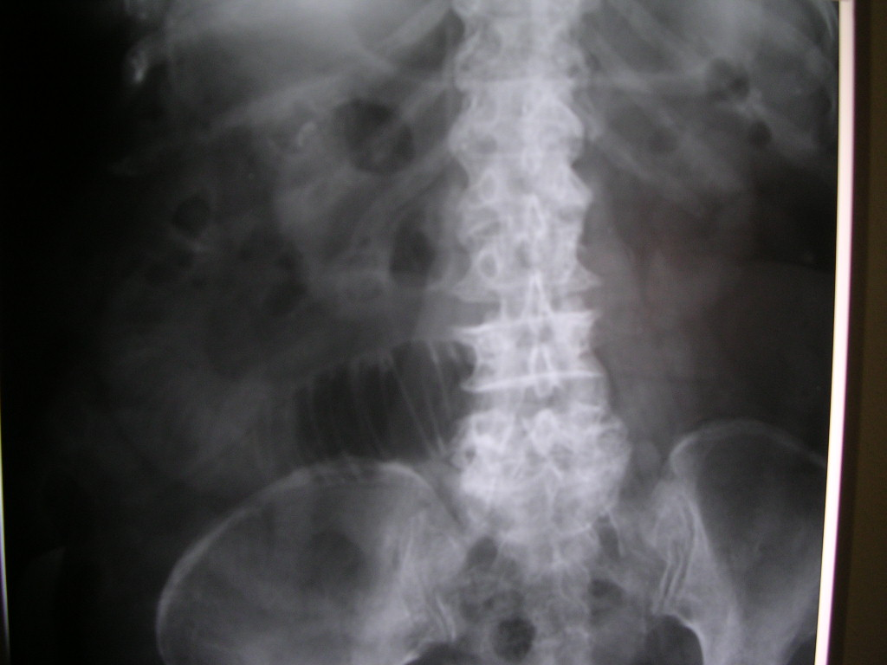
Image 1

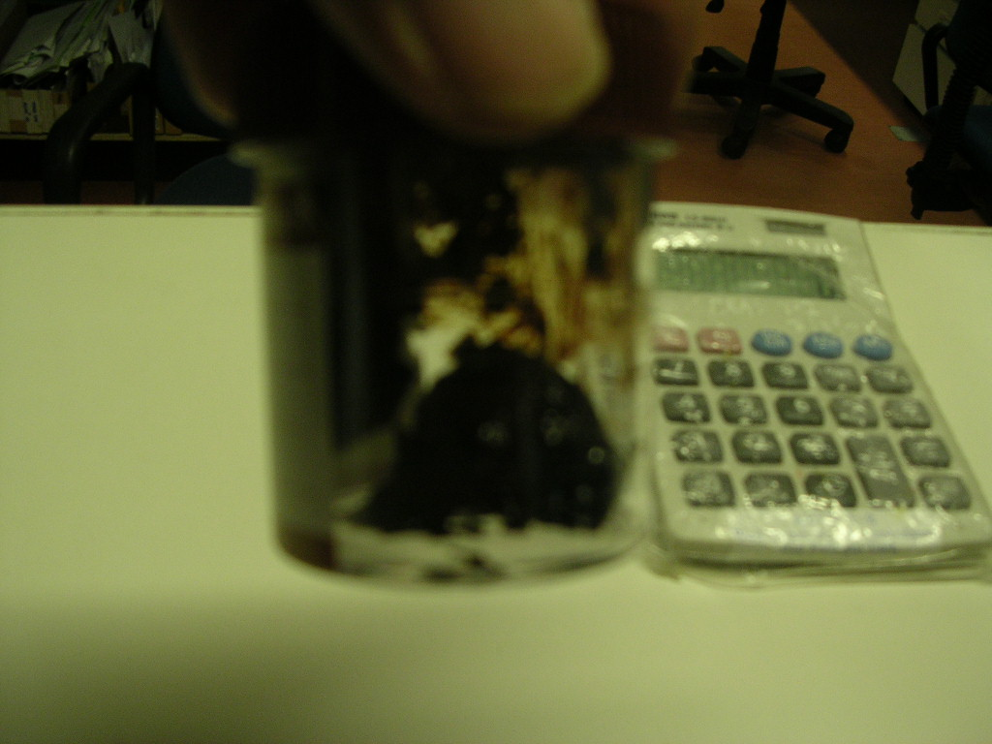
Image 2

His Hemoglobin was 5.6gm/dl with normal Total white and platelet count.. Hematocrit level was 26 percents. Abdominal x-ray was normal. Full blood picture showed Normocytic Normochromic anemia. Patient was put on intravenous fluids and blood transfusion. He was then sent for Meckel’s Scan at Hospital Kuala Lumpur on the same day. The images showed focal accumulation of ectopic gastric mucosa lateral to rectus abdominus at right Iliac fossa consistent with Meckel’s diverticulum (image3).

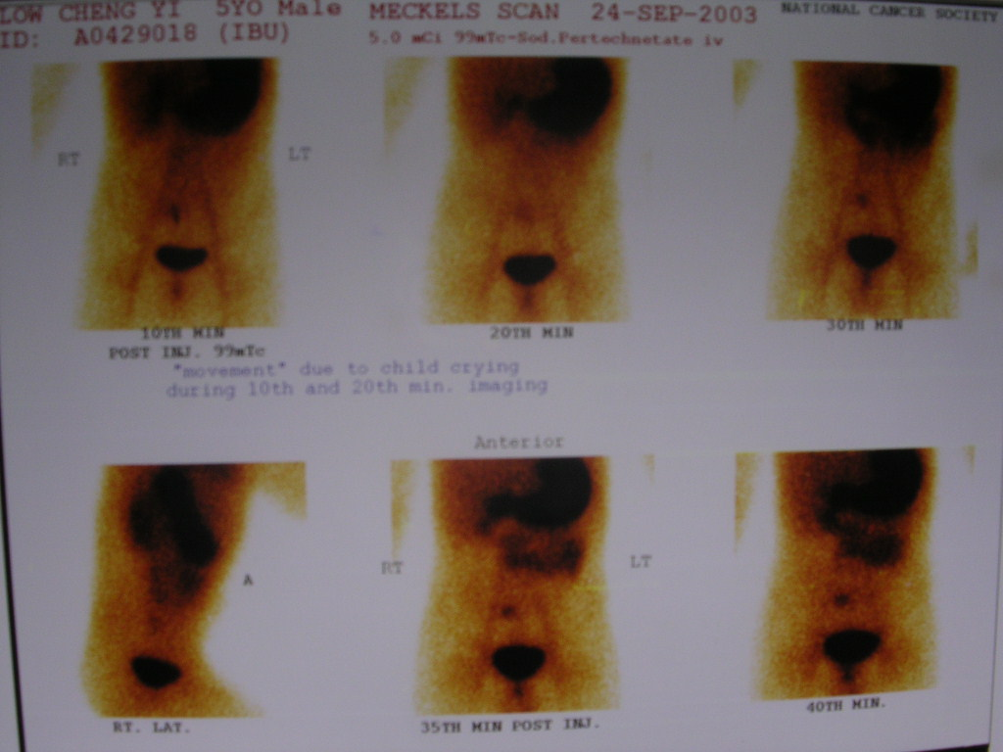
Image 3

Subsequently patient was subjected to surgery through Lanz incision. Operative findings showed a Meckel’s diverticulum at 29cm from ileo-caecal junction with base measured about 2.3cm (image 4). A segmental resection of small bowel and primary anastomosis were performed together with appendicectomy which was normal. On examining of the mucosa it showed evidences of bleeding with clots and erosions (image 5).
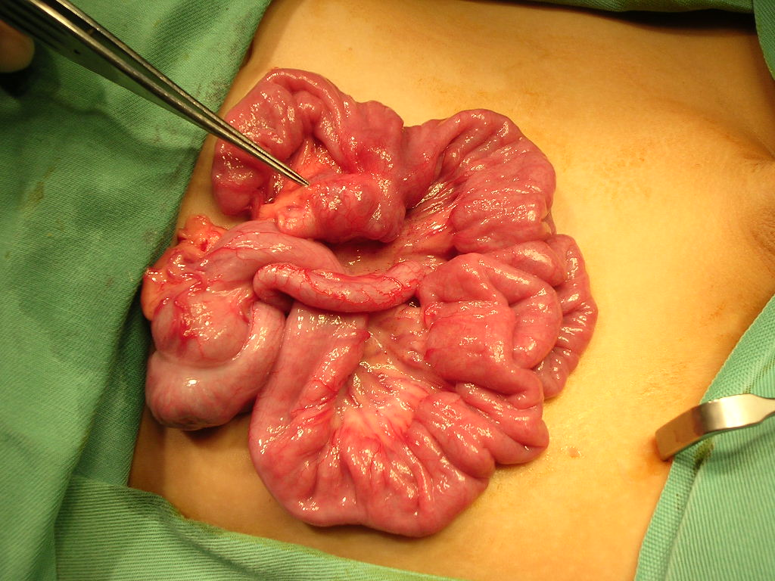
Image 4

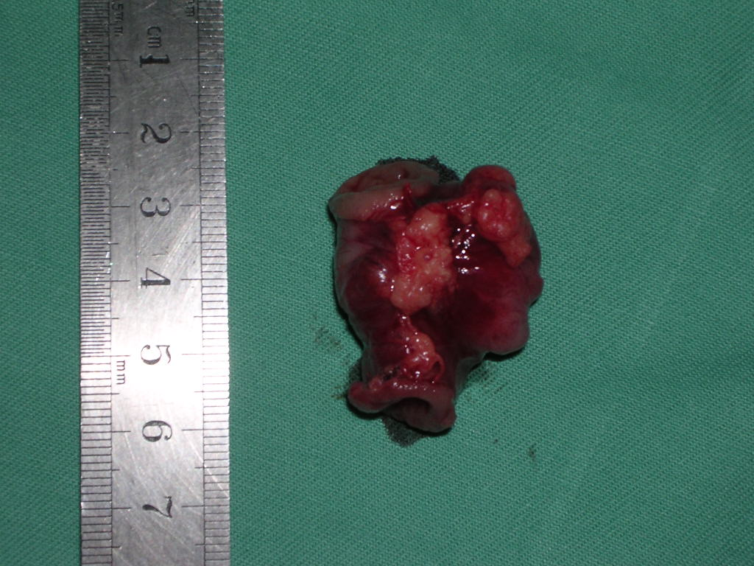
Image 5

Post operatively patient was recovering well. He was put on feeding as early as Post operative day 2 and discharging home on Post operative day 4.

DISCUSSIONS:

When patient presents with bleeding and with suspicion of Meckel diverticulum, diagnostic evaluation should include ⁹⁹tech scan or so call Meckel scan. After intravenous injection of the isotope, the gamma camera is used to scan the abdomen¹. The procedure usually last about 30 minutes. Gastric mucosa detects the radioactive isotope; thus, if the diverticulum contains parietal cells in the gastric mucosa, it is depicted as a hot spot.

Advantages of the scan are that the procedure is non invasive and involves less radiation exposure than that from an upper gastrointestinal and small bowel follow through study.
²To be visualized, The MD must be actively bleeding at a minimum rate of 0.1mL per minute. Sensitivity varies from 75-11 percents; false positive results occur in up to 15 percents of patients. This scan provides 95% accuracy for detection of gastric mucosa. False positive results on the scan can be due to duodenal ulcer, small-intestinal obstruction, ureteric obstruction, aneurysm and angioma. False negative results can be when gastric mucosa is very slight or absent in the MD.

²During workup of patients, the barium study should never precede the Tc 99m scan because barium may obscure the hot spot if present. Sometimes, scintigraphy can be performed with the use of other agents, such as Tc 99m-sulphur colloid or Tc 99m-red blood cells.

²Selective arteriography may be helpful in patients whom results from scintigraphy and barium studies are negative. When the rate of bleeding more than 1mL per minute, a superior mesenteric arteriogram can be helpful. Demonstration of abnormal arterial branches, dense capillary staining, or extravasation of the contrast medium confirms MD.

Traditional small- bowel series using barium has been unreliable in the detection of MD. However, for patient require further study, enteoclysis is considered to be a better technique for this purpose. This procedure involves using a continuous infusion of barium with adequate compression of the ileal loops and fold pattern cannot be visualized, carboxymethylcellulose sodium can be used as a medium in this patients.

Characteristic radiologic signs for MD include demonstration of a triradiate fold pattern or a mucosal triangle. Ocasionally, a gastric rugal pattern may also be found within MD. If intussusception is suspected, barium enema can be performed. Abdominal CT is usually not helpful because differentiating MD from small bowel loops is difficult²

Most symptomatic patients are acutely ill, fluids resuscitation must be commenced immediately. When a child presents with bleeding, specifically dark tarry stool, perform gastric lavage to rule out upper GI bleeding. In the setting of negative Meckel scan with a high clinical suspicion of MD, the surgery team should consider the need for laparoscopy

REFERENCES;

1.Brown RL, Azizkhan RG, Gastrointestinal bleeding in infants and children: Meckel’s diverticulum and intestinal duplication. Semin Pediatr Surg. 1999 Nov;8(4): 202-9.

2. Mettler Fred A. Jr., Guiberteau Milton J. Essentials of Nuclear Medicine Imaging. 4th Edition. 1998. W.B. Saunders Co., Philadelphia, PA.pp. 300-303.

3. Prem C Shukla, Simon S Rabinowitz : Meckel Diverticulum. eMedicine. December 2002.

Surgical management of Gall stone Ileus

Abstract:

Gallstone ileus is a surgical emergency that occurs almost exclusively in the elderly. It is of increasing significance with current demographic changes. We describe a patient who presented with mechanical obstruction of the small bowel secondary to impaction of the distal ileum from a gallstone.. Surgical management is the gold standard for the management of gallstone ileus. Non invasive procedures such as colonoscopy is an alternative if surgery is contraindicated. A review of the literature is also presented.
Key Words: Gallstone Ileus; Bouverete’s disease.

Introductions:
Gallstone ileus (GSI) is a surgical emergency defined as a mechanical obstruction caused by intraluminal impaction of one or more gallstones anywhere between the stomach and the rectum. First described by Bartholin in 1654, the condition is uncommon, comprising 1 to 4% of all cases of intestinal obstruction.¹ With increasing life expectancy, GSI is being encountered more frequently and accounts for 25% of nonstrangulated small bowel obstruction over the age of 65.² Accurate preoperative diagnosis is made in 24 to 73% of patients, and the mean/median duration between admission and operation is 2 to 5 days. Although GSI has been reported in patients as young as 13 years,² it is indeed a disease of the elderly, with a mean age at presentation of 65 to 75 years.
Abdominal pain and vomiting are constant but non-specific features of GSI,¹ and 14 of our patients presented this way. Only 50 to 70% of patients present with clear features of intestinal obstruction. The obstructing gallstone "tumbles" down the gastrointestinal tract, causing an intermittent partial or complete obstruction as it impacts and disimpacts. Abdominal distension and absolute constipation are therefore inconstant, and patients often have diarrhea. Disimpaction of the stone results in relief of symptoms and may lead to an erroneous diagnosis of subsiding gastroenteritis.

Case History:
Mrs. B, a 81 years old Malay, female with previous history of hypertension on medication presented to surgical ward in September 2003 two days history of not passing motion and flatus She also had associated generalized abdominal pain, nausea and bilious vomiting with on and off low grade fever. On examinations, she looks dehydrated with slightly tachycardia. Her Blood pressure measured 150/92 mmHG. Abdomen was distended and tenderness present at the Right Iliac fossa and epigastrium regions.Bowel sound was sluggish. No other significant positive findings per abdomen. Digital rectal examination revealed empty rectum with no evidenced of lower or upper GI bleed. Other systemic examinations were normal.

Early diagnosis as acute small bowel obstruction was made. Subsequently patient was put under fluid resuscitation. Nasogastric tube was in placed and initial aspirates was about 760mls of greenish fluids. Abdominal X-ray showed dilated loops of small bowel with free air seen on the right upper quadrant of abdomen.Thickening of bowel wall seen. After stabilizing the patient, exploratory laparotomy was performed .

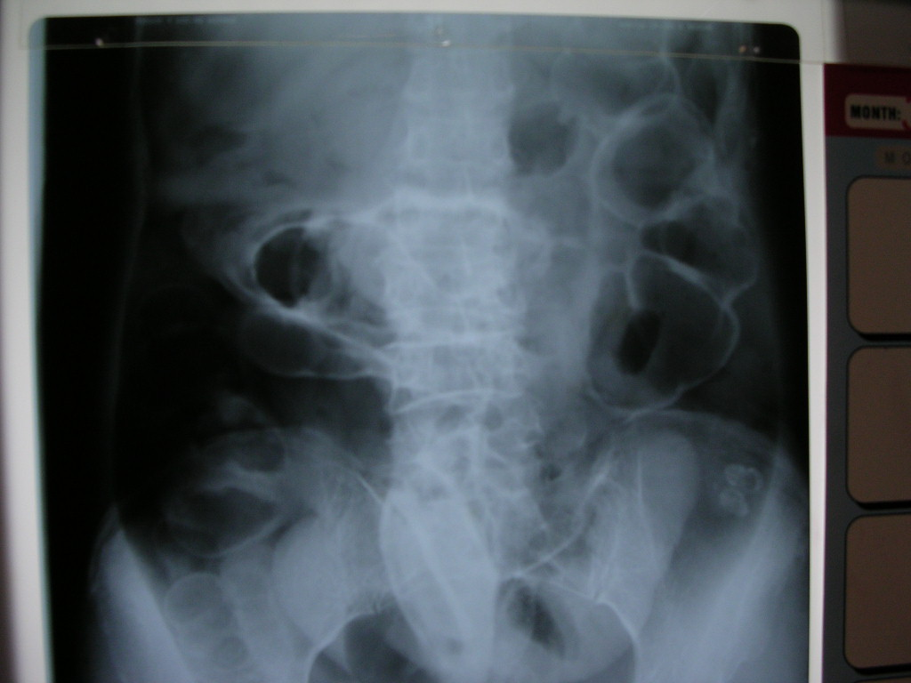
Abdominal x-ray

Intraoperatively , a fistula was found between gall bladder and duodenum. Gall baldder was grossly dilated. A pigmented bile stone measuring about 4 X 4cm was found obstructing the distal ileum (12 cm from ileo-caecal junction). Parts of small bowel proximal to the impaction site inflamed. Enterostomy was performed at the site of impaction and pigmented stone removed. No attempt made to revert the a chole-duodenal fistula. On further evaluation no stone noted remains in gall bladder.

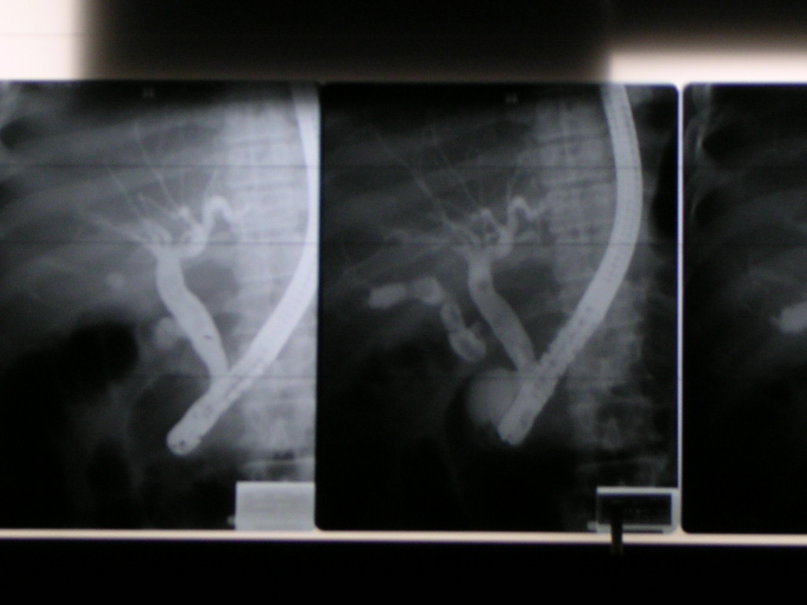
Cholangiogram

On post op day 7 ERCP was performed on her and contrast seen in the billiary tree as well as at the fistulous communication. Post operatively, patient developed ileus and recovered after day 5 and subsequently discharged from ward on day 10 . She was asymptomatic at follow-up clinic a month ago exactly 6 month after surgery .

Discussions:

Gallstone ileus results in considerable morbidity and mortality. The overall mortality rate is 12%; 10% in patients who underwent surgery and 21% in patients treated conservatively.¹ The majority of the patients are over the age of 50 years. Approximately 1-2% of the cases of mechanical intestinal obstruction are caused by gallstone ileus, and this occurs much more commonly in patients over 65 years of age. The most common cause of gallstone ileus is due to the formation of a biliary-enteric fistula. In a review of 112 patients with gallstone ileus, 53% of the patients had cholecystoduodenal fistula.¹ The other sites of fistulae were between the gallbladder/common bile duct and the colon, in the stomach, or, in some cases, in multiple sites.¹⁻³
Delayed gallstone ileus two months after endoscopic retrograde cholangiopan-creatography and common bile duct stone extraction has been reported.⁴ The most common site of gallstone impaction is the terminal ileum,⁵ the other sites being the duodenum, the gastric outlet (Bouveret's syndrome), and the colon. The gallstone should be at least more than 2.5 cm in diameter to cause intestinal obstruction. In one series of gallstone ileus, 64% of patients who recovered after surgery for gallstone ileus had an average stone diameter of 4.5 cm; whereas, in seven patients who died despite surgery, the average stone diameter was 5.2 cm¹ In eight cases of spontaneous passage, the stone averaged 3.2 cm in diameter. Most patients with gallstone ileus present with symptoms of intermittent mechanical bowel obstruction due to downward migration and intermittent impaction of the stone at various levels of the gastrointestinal tract, leading to delay in diagnosis. Only 25% of patients with gallstone ileus have history of biliary colic in the preceding one year.¹
Preoperative diagnosis is made in only 13-48% of gallstone ileus cases. The most important investigation in the evaluation of the gallstone ileus is a scout film of the abdomen. The radiological criteria described by Rigler et al.⁶ in scout or contrast films of the abdomen are pneumobilia or contrast found in the biliary tree, distended small bowel loops, a gallstone in the small bowel, or a change in the position of the demonstrated gallstone. Lasson et al.⁷ suggested that the high morbidity and mortality of gallstone ileus can be reduced if ultrasonography is used in cases of undiagnosed abdominal pain in elderly patients with protracted symptoms.
There is a paucity of data regarding the role of endoscopy in the management of gallstone ileus. Several cases of Bouveret's syndrome, where a stone was visualized endoscopically, have been published. A case of Bouveret's syndrome managed successfully by endoscopic stone extraction has been described.⁷ Endoscopic electrohydrolic lithotripsy after failed extracorporeal shockwave lithotripsy for Bouveret's syndrome has been reported. Colonoscopy has been useful in the diagnosis and relief of large bowel obstruction secondary to gallstone impaction. In gallstone ileus, surgical treatment is recommended no matter where the stone is located. The appropriate surgical intervention for gallstone ileus is controversial.
The choices are enterolithotomy alone or enterolithotomy in combination with cholecystectomy, division of the fistula, and common bile duct exploration, if indicated. Other methods to treat gallstone ileus, such as extracorporeal shock-wave lithotripsy, have been reported. Gallstone ileus managed by laparoscopic-assisted enterolithotomy has been described.⁷ In our patient, we choose not to perform colonoscopy as she had sign and symptoms of peritonitis.
In conclusion, even though surgical management of gallstone ileus is the gold standard, endoscopic therapy can be attempted in patients with gallstone ileus who are not surgical candidates.

REFERENCES
1. Kasahara Y, Umemura H, Shiraha S, Kuyama T, Sakata K, Kubota H. Gallstone ileus: review of 112 patients in Japanese literature. Am J Surg 1980;140:437-40.
2. Anderson RE, Woodward N, Diffenbauch WG, Strohl EL. Gallstone obstruction of the intestine. Surg Gynecol Obsiet 1967;125:540-8
3. Wakefield EG, Vickers PM, Walters W. Intestinal obstruction caused by gallstones. Surg 1939;5:670-3.
4. Williams IM, Hughes OD, Hicks E, Lewis MH. Gallstone ileus following multiple endoscopic retrograde cholangiopancreatographies. J R Coll Surg Edinb 1997;42(6):423.
5. Foss HL, Summers JD. Intestinal obstruction from gallstones. Ann Surg 1942;115:721-35.
6. Oikarinen H, Paivansalo M, Tikkakoski T, Saarela A. Radiological findings in biliary fistula and gallstone ileus. Acta Radiol 1996;37:917-22
7. Cooperman AM, Dickson ER, Remine WH. Changing concepts in the surgical treatment of gallstone ileus: a review of 15 cases with emphasis on diagnosis and treatment. Ann Surg 1968;167:377-83.

acute intermittent porphyria
Presented as surgical emergency

Abstracts;

Most of patient presented with acute attack of abdominal pain need to exclude the common surgical emergencies such as acute apendicitis, pancreatitis, cholecystitis, perforated viscus as well as renal colic. In elderly other uncommon pathology such as leaking Abdominal Aortic Aneurysm should also need to be rule out. Acute intermittent porphyria (AIP) is a medical condition that can be presented as an acute abdomen. Clinical features and diagnostic evaluations of AIP are discussed here.

Keywords: porphyria, neuroporphyrias, cutaneous porphyrias.

Introductions:

The word porphyria derives from Greek word porphuros, which means red or purple ¹ . The porphyries are a group of rare metabolic disorders arising from reduced activity of any enzymes in the heme biosynthetic pathway. The disorders may be either acquired (for instance through a toxin) or inherited through genetic defect in a gene encoding these enzymes. These deficiencies disrupt normal heme production, with symptoms especially prominent when increased heme is required. Porphyrin precursors, overproduced in response to synthetic pathway blockages, accumulates in the body ², cause diverse pathologic changes, and become the basis for diagnostic tests.

There are two neuroporphyrias ( acute intermittent porphyria and plumboporphyria) and two neurocutaneous porphrias (hereditary coproporphria and variegate porphyria). Classical triad of an acute intermittent porphyries are abdominal pain, peripheral neuropathy and changes in mental status. Severe abdominal pain is the most commonly reported presenting symptom during an acute attack.

Case History:

Mrs A, a 34 year old malay lady ,known hypertension on treatment, married with no significant previous psychiatric history was presented to surgical ward several times in September 2003 with complaints of epigastric pain. The pain has been there on and off since last four and a half months. It present almost everyday and aggravated by food. It was dull aching non radiating and occasioanally associated with vomiting.The pain was not relieved on postural manouvre. On each admission she require intravenous infusion of Pethidine (100mg in 50mls at 3 mls/hr) No history of fever, Jaundice or diarrhea. Urine and stool colour were normal. No signs of peripheral neuropathy. No history of dysmenorrhoea or menorrhagia.

She has lost about 10 kg for the past 4 months. Earlier in April 2003 she was admitted to Medical ward with similar complaint and diagnosed to have Diabetes Mellitus and was started on Glibenclamide. She was again admitted to surgical ward exactly a month ago for recurrent abdominal pain. During her last visit, general as well as systemic examinations were normal. Serum amylase was not raised. OGDS and colonoscopy were normal. An ultrasound abdomen showed hypoechoic lesion at segment 4 most likely to be hemangioma. CT Scan abdomen was also arranged and no other abnormality except horshoe kidney was detected.

Blood investigations showed low serum Pottasium (2.8meq/L). Normal serum sodium,calcium,phosphate and magnesium. Her Total Iron Binding capacity was 40.3( N46.5-79.6) slightly low. Subsequently we sent 3 samples of urine porphobilinogen during attack of pain and the 2nd sample turns out positive. Hence she was referred to neurologist. A full neurological examinations were normal . She was given oral Tramadol 50mg thrice a day together with oral Pottasium and hematinics supplements. The symptoms disappeared and patient was discharged home with hematinics. However she did not come for further follow up.

Discussions

The four acute porphyries are clinically indistinguishable during acute attacks ¹ , particularly because patients with variegate porphyria and hereditary coproporphyria may not exhibit dermatologic changes. The variability of clinical course, the lack of understanding of an appropriate diagnostic process, and the lack of a universally accepted standard for test result interpretation add to the difficulty of making diagnosis.

Reported clinical manifestations of acute porphyria include neuropychiatric symptoms and clinical signs(hysteria, anxiety, depression,phobias,psychosis, agitation, delirium, restlessness, seizures, neuropathy, sensory involvement and hyporeflexia), autonomic instability (hypertension, tachycardia, abdominal pain, nausea, vomiting, and constipation), dehydration and electrolyte imbalance (hyponatremia, hypokalemia, and hypocalcemia), and dermatologic features (photosensitivity, skin fragility, hypertrichosis, and hyperpigmentation)¹⁻³.

Abdominal pain, peripheral neuropathy, and changes in mental status are the classic triad of an acute attack³ . A clinical presentation without abdominal pain is unusual in acute porphyria, and some authors suggest that initial screening tests should be limited to patients with this symptoms^{4,5} . Among patient with acute porphyria, 20%-58% have neuropsychiatric symptoms during acute exacerbations. The pathogenesis of neuropsychiatric manifestations remains unclear but multiple hypotheses have been reported including CNS metabolic abnormalities, ischemia, demyelination, oxidative stress and nervous tissue heme deficiency¹⁻⁴.

Acute attacks for all four acute porphyries are invariably associated with increased urinary excretion of aminolevulinic acid or porphobilinogen or both. Therefore quantitative measurement of 24-hour urinary excretion of porphobilinogen and aminolevulinic acid during symptomatic period is the most helpful method of determining whether a particular set of symptoms and signs is due to acute porphyria. If levels of urine porphobilinogen or aminolevulinic acid or both are increased, diagnosis of an acute porphyria attack can be made. When urine porphobilinogen is elevated more than 2 to 5 times its normal limits, an acute attack of acute intermittent porphyria, variegate porphyria or hereditary coproporphyria should be suspected. Acute intermittent porphyria should be distinguished from the other two by normal or near normal levels of fecal porphyrin⁵ . Unfortunately our laboratory facilities does not provide the test. Reduced activity of erythrocyte porphobilinogen deaminase further supports the diagnosis of acute intermittent porphyria^{5 .}.

In variegate porphyria, the preponderant stool porphyrine is protoporphyrin, which concentrations ranging from 3 to 7 times the normal value. In hereditary coproporphyria, the concentration of stool coproporphyrinogen is at least 5 times normal. In our patient, concentration of urine pophyrins were 3 times than normal. False negative results of urine porphyrin quantitation may be caused by a time lag between sample colletion and testing. Since porphyrins are light sensitive, specimens must be stored in the dark and tested as soon as possible. When exposed to normal lighting, urine porphyrin concentration is reduced by 50% in 24 hours¹ .

Management strategies in acute episodes are limited, and therapy is mainly supportive ² . Treatment mainstays include identifying and limiting possible precipitants, maintaining adequate intake of carbohydrates and fluids, and administering haem arginate. Environmental factors such as low carbohydrate diet, infection, psycologic stress, excessive alcohol intake and sun exposure may precipitate attack. Haematin- most typically in the form of haem alginate is the only form of heme that currently approved for use in United states during acute attack. By negative feedback it suppresses aminolevulinic acis synthase. Within hours the over excretion of enzymes are normalized and within 2 to 4 days most patients with acute porphyria show clinical improvements.

In retrospect, our patient’s features were slightly similar to what is documented in the literature with the exception of absent of neurological manifestations. However diagnosis was entertained because of the following: 1) after excluding all the possibilities of surgical causes, 2)unexplained weight loss , 3) electrolyte imbalance , 4) Reduced Total Iron Binding Capacity (TIBC), and 5) Raised urine porphobilinogen levels. Results from quantitative tests for porphyrins in both urine and stool are proven valuable in making a diagnosis sooner.

References

- Crimlisk HL: The little imitator-porphyria: a neuropychiatric disorder. J Neurol Neurosurg Psychiatry 1997; 62:319-328.
- Ashley EM: Anaesthesia for porphyria.Br J Hosp Med 1996; 6;37-42.
- Thadani H, Deacon A, Peters T: Diagnosis and management of porphyria. Br Med J 2000; 320: 1647-1651.
- Mattern SE, Tefferi A: the cost of suspicion. Am J Med 1999; 107 621-623.
- Kauppinen R, Timonen K, Mustajoki P: Treatment of the porphyries. Ann Med 1994; 26:31-38
Short Bowel Syndrome (SBS)

Abstract

Short bowel syndrome (SBS) comprises the sequelae of nutrient, fluid, and weight loss that occurs subsequent to greatly reduced functional surface area of the small intestine. 1 In adults, the most common causes of SBS include Crohn's disease, acute bowel infarction, radiation strictures, and adhesive obstruction. Here, we presented a pregnant lady with an acute bowel ischemia required massive resection of small bowel end up with short bowel syndrome. The nutritional management of the SBS is discussed here.

Keyword: SBS, ischaemic bowel

Introductions

SBS occurs when greater than 70% to 75% of the small intestine is resected (the average normal length is approximately 600 cm). This reduced absorptive surface area leads to an abnormally rapid transit of intestinal contents. Prognosis for patients with SBS is related to the length of remaining bowel. Although almost all nutrients are usually absorbed in the first 100 to 150 cm of the small bowel, the specific region of the bowel resected determines the nutritional needs of patients because certain areas of the small intestine are more efficient at absorption than others.
Resections of the duodenum alone are rare and do not result in SBS, although they do play a role in dumping syndrome. Removal of the duodenum causes poor tolerance of concentrated sugars, lactose intolerance, and malabsorption of calcium, iron, and folic acid. ¹ A low duodenal pH may also cause malabsorption of glucose. The jejunum ranges from 200 to 300 cm long. Resection of the jejunum is not as common as more distal bowel resections. Although the jejunum is also responsible for absorbing vitamins and minerals, proteins, carbohydrates, and fats, the ileum is usually able to compensate for these absorptive functions if the jejunum is removed.
The ileum, however, cannot compensate for the reduced levels of jejunal inhibitory enterohormones such as gastric inhibitory peptide and vasoactive peptide that result from jejunal resections. Gastric hypersecretion subsequent to increased production of gastrin occurs to a greater extent after jejunal resections than ileal resections. The increased gastric secretions and acidity inactivate pancreatic enzymes, reducing the efficiency of protein and lipid digestion. The excess gastric acid and low intraduodenal pH may damage the bowel mucosa, inactivate digestive enzymes, and stimulate peristalsis. Decreased secretion of cholecystokinin and secretin further reduces gallbladder contraction and pancreatic secretion. These factors along with secretion of a high salt load by the stomach may compound the diarrhea associated with SBS. ¹
Patients with a jejunostomy may initially experience problems with electrolyte and fluid balance because liquids empty rapidly, although solids empty normally Patients who have 60 to 100 cm of jejunum intact tend to have large stomal outputs and absorb less than 35% of energy available. Extensive sodium depletion may lead to hypotension and prerenal uremia. Chronic sodium loss may be associated with low plasma volume, reduced sodium output in urine, and increased plasma aldosterone. ¹
The ileum ranges from 300 to 400 cm (equivalent to 12 ft), with the distal 100 cm being the most critical physiologically. ¹ Although the ileum plays a small role in the digestion and absorption of macro- and micronutrients, its slower rate of peristalsis explains the fact that distal resections of the small intestine lead to more complications than do proximal resections.Interestingly, the functional length of the ileum is almost double that of the jejunum. Resection of the ileum may destroy the ileal brake that tends to slow transit through the stomach and proximal small bowel; this results in decreased interaction among the absorptive surface area, luminal contents, and the digestive juices.

Case History

Mrs M, a 26 year old ,G2P1 at 8 week of gestation presented to gynecology ward with history of generalized abdominal pain and distension for 3 days duration. It is associated with vomiting and no bowel opening for 2 days. No history of PV bleeding. On examination patient was dehydrated and looks very lethargic .Abdominal examination revealed tenderness at the right hypochondrium and epigastric region with generalized guarding. She was scan by gynecologist showing normal intrauterine pregnancy. The case was referred to us to rule out acute abdominal condition. Subsequently repeat ultrasound done by radiologist showed free fluids present in the abdomen and pelvis of questionable cause. 12 hours after admission she developed fever (38.5 degree Celsius), tachycardic with white cell count was 25.5 . Diagnostic laparoscopic was planned initially but in view of generalized peritonitis exploratory laparotomy was performed.

Findings was a gangrenous small bowel about 100cm in length extending 19cm from duodeno-jejuno junction secondary to superior mesenteric vein thrombosis. Length of viable bowel from ileo-caecal valve was 130cm. The rest of intraabdominal visceras including uterus was normal. Resection with primary anastomosis was done with IV Heparin started immediately postoperatively. She was monitored in ICU for 2 days before discharged to general ward. On post-operative day 5 her abdomen becomes distended again. No bowel opening since surgery. Relaparotomy was performed on D6 and another segment of bowel become gangrenous including the previous anastomotic site. Further resection left only 70 cm of jejuno-ileal upto ileocaecal valve.

She was immediately put on TPN post-operatively with low molecular weight Heparin. She was kept nil by mouth upto a week before slowly being put on nourishing fluids containing elemental diet. She was allowed to continue her pregnancy by gynecology team only to have an abortion at POG of 16 weeks. TPN was continued for about 2 weeks before patient can fully take normal diet. She has been experiencing diarrhea (6-7 times a day) for about 10 days, before recovering her normal bowel activity. She was discharged from the ward on post operative day 20 with elementary diet supports and oral anticoagulant (patient no-compliant to LMWH). She was last seen in our follow-up clinic on 28th May 2004. She lost about 7 Kg since being discharge, though she looks healthy clinically. She was advised for intermittent parenteral nutrition but refused. Currently she has not experiencing any change in bowel habits. She has been referred to dietitian for advising regarding her nutritional support.

Discussions

Thorough nutritional management is the key factor in achieving an optimal outcome in SBS. Total parenteral nutrition (TPN) is necessary in the early stages, as is replacement of excess fluid and electrolyte losses. Nutritional management of SBS has traditionally been divided into two phases: an acute phase and adaptation phase.
The acute phase, occurs during the immediate postoperative weeks and may last 1 to 3 months. This phase is marked by poor absorption of almost all nutrients, including water, electrolytes, proteins, carbohydrates, fats, vitamins, and trace elements. ¹Fluid loss from the gastrointestinal tract tends to be greatest during the first few days after massive small intestinal resection; ostomy outputs may exceed 5 L/d. Aggressive fluid and electrolyte replacement therapy is necessary to reduce life-threatening dehydration, hypotension, and electrolyte imbalances. Frequent measurements of vital signs, intake and output, and central venous pressures are required because of rapid metabolic changes and possible hemodynamic instability¹
Almost all patients with SBS have abnormal liver function; most will experience transient hyperbilirubinemia. ¹ This may be caused by of the translocation of microorganisms and/or their toxins through ischemic or gangrenous intestinal mucosa into the portal vein secondary to the reduced mesenteric venous return subsequent to massive small-bowel resection. ²
Recommendations regarding the need for parenteral nutrition vary depending on the presence or absence of three key structures: jejunum, the ileocecal valve, and functional colon. If the duodenum and 60 cm of jejunum or ileum remain intact, a favorable prognosis is likely. ³Furthermore, the ileocecal valve can effectively increase the absorptive capacity of the remaining small bowel up to two times that expected for the same length of small bowel without an intact ileocecal valve. Patients who retain less than 50 cm of jejunum will usually need parenteral nutrition permanently even if most of the colon is functional. Patients with jejunostomy whose total small intestinal remnant is less than 100 cm will also require TPN; however, some jejunostomy patients with more than 100 cm of small intestine may still require parenteral supplementation of water and minerals. ⁴ Patients with less than 30 cm of bowel and a competent ileocecal valve will require indefinite home parenteral nutrition, as will patients with less than 60 cm of small bowel without an ileocecal valve.
Phase II, the adaptation phase, generally begins within 24 to 48 hours after resection and may last from 1 to 2 years. During this period, 90% to 95% of the bowel adaptation potential (including nutritional and metabolic stability) has been realized, and only 5% to 10% of additional improvement in bowel adaptation and absorption is possible. ¹ Adaptive changes also take place in the stomach, pancreas, and colon. Clinical manifestations of intestinal adaptation include weight change and stabilization of fluid and electrolyte levels. ³
Adaptation involves increased mucosal surface area through enterocyte hyperplasia and migration within the villus leading to villous hyperplasia and increased crypt depth. Intestinal dilatation and lengthening also occur. Distal resection tends to show a greater adaptive response than more proximal resections; that is, the ability of the ileum to adapt is greater than that of the jejunum, although the jejunum is capable of enhanced absorption
Luminal nutrition is essential for complete adaptation and should be initiated as early as possible. Other trophic influences include pancreaticobiliary secretions and gut hormones such as enteroglucagon, gastrin, epidermal growth factor, and insulin-like growth factor.
If the total amount of small intestine remaining is 100 cm or less, TPN is essential for survival. In such cases it is unrealistic to assume that adaptation will occur to an extent that will allow the patient to rely completely on enteral nutrition. When transition from TPN to enteral nutrition is possible, enteral feedings are preferred because they help to maintain a stable body weight and prevent large fluctuations in fluid balance. ⁵Some researchers consider enteral nutrition to be the most important stimulus for adaptation. Total parenteral nutrition should be gradually reduced, as enteral nutrition is gradually increased. For example, attempts to wean from TPN may be accomplished by first decreasing the volume administered to 1 L/d and then by reducing the frequency of administration to every other day, then every third day, etc
Because parenteral nutrition without concomitant enteral feeding may suppress the appetite and lead to mucosal hypoplasia, luminal nutrients play an important role in adaptation. In fact, villous atrophy caused by TPN or surgical bypass has been reversed in some cases by administration of luminal nutrients⁶. The presence of nutrients in the lumen seems to promote an adaptive hyperplasia that results in increased length and weight of the intestines. Migration and proliferation of cells from the intestinal crypts leads to an increase in the cell population of both the mucosa and the villi. Absorption per unit of intestinal length also increases. Enterocyte enzymes may also be stimulated commensurate to the composition of the luminal feeding given.⁶ Enteral nutrients (e.g., glutamine, soluble fibers, and SCFAs) act directly via contact with intestinal epithelium; they also act indirectly to stimulate the secretion of intestinal trophic hormones (e.g., growth hormone, epidermal growth factor, enteroglucagon, insulin-like growth factor I). Oral replacement fluids might be used initially, followed by a dilute, defined-formula diet.Patients with very short bowel (<60 cm) and those who do not tolerate oral feeds should be maintained on a defined-formula diet. This may be accomplished by constant infusion, starting with a diluted diet infused at approximately 25 mL/h. ⁶ Both the concentration and rate should be increased commensurate with the patient's tolerance until a concentration of 100 to 125 mL/h is reached.
With resections greater than 75%, complete adaptation may take 6 months to a year; therefore, it is important to refrain from excessive enteral or oral nutrition before the patient is truly ready for such support. Continuous-drip feedings may provide maximal stimulation and hasten recovery time. Small feedings of isotonic liquids and solid foods should be initiated with improvement of the patient's condition. Total parenteral nutrition may occasionally be necessary even after adaptation has occurred; therefore, the patient's nutritional status should be monitored closely throughout life.
Total intestinal adaptation is considered to be achieved when patients are able to discontinue parenteral feeding. Even if TPN is used to supply the majority of calories and nutrients, enteral feeding should be initiated as soon as possible to expedite adaptation of the remaining bowel. Provided that the intestinal mucosa is relatively healthy, the lower limit for the length of small bowel necessary to be weaned from TPN ranges from 50 to 70 cm of small bowel if the colon is left intact, or 100 to 150 cm if the resection includes a colectomy. Elemental formulations contain monoglycerides, free amino acids, dipeptides and tripeptides, and occasionally, medium-chain triglycerides. Elemental diets are very efficiently absorbed within the first 100 cm of jejunum. They may also facilitate adaptation by preserving intestinal mass in the proximal small bowel. Conversely, elemental diets tend to be unpalatable, are hyperosmolar, and may increase diarrhea if administered at full strength. In most cases, elemental diets must be given through a nasogastric tube.
Polymeric diets are easily taken orally, are less hyperosmolar, and are much less expensive than elemental formulations. ⁷ For these reasons, most clinicians tend to prescribe polymeric diets initially, providing elemental diets only to those patients who are unable to tolerate polymeric formulas. ⁸ Some studies show that polymeric diets provide greater stimulation of the mucosa compared with elemental diets. Furthermore, low-residue, polymeric, chemically defined, or elemental diets offer the theoretical advantage of being easily absorbed in patients with SBS. However, some researchers argue that there is no significant difference in caloric absorption, stomal output, or electrolyte losses among elemental, polymeric, and normal diets in patients with SBS. When gastrointestinal fluid losses increase, it may be assumed that enteral feedings are no longer tolerated.

References

1. Byrne TA, Nompleggi DJ, Wilmore DW. Advances in the management of patients with intestinal failure. Transplant Proc 1996; 28:2683–90
2. Sturm A, Layer P, Goebell H, et al. Short-bowel syndrome: an update on the therapeutic approach. Scand J Gastroenterol 1997; 32:289–96.
3. Scolapio JS. Effect of growth hormone and glutamine on the short bowel: five years later [review]. Gut 2000; 47:164
4. Thompson JS. Inflammatory disease and outcome of short bowel syndrome. Am J Surg 2000; 180:551–5
5. Skipper A. Dietitian's handbook of enteral and parenteral nutrition. Rockville, MD: Aspen, 1989.
6. Weireiter L. Nutritional hope or hype for short bowel syndrome? Am J Gastroenterol 1996; 91:2246–7
7. Stump ES. Nutrition and diagnosis-related care, 3rd ed. Philadelphia: Lea & Febiger, 1992.
8. Dudrick SJ, Latifi R. Management of short-bowel syndrome. In: Kirby DF, Dudrick SJ, eds. Practical handbook of nutrition in clinical practice. Boca Raton: CRC Press, 1994.

Castleman’s disease

Abstract:

Castleman's disease (CD), a rare condition of uncertain etiology, involves a massive proliferation of lymphoid tissues and typically presents as mediastinal masses. We describe a patient with CD who presented with diffuse adenopathy involving the inguinal, spleen, retroperitoneal, axillary, and pelvic regions. The management of the CD is discussed here.

Keyword: CD, hyaline vascular, Interleukin 6

Introductions:

Castleman's disease (CD) involves a massive non-malignant proliferation of lymphoid tissues and typically presents as mediastinal masses. This uncommon condition was initially described among a small series of patients in 1956. ¹ Castleman's affects patients of varying ages and cases have been reported from adolesence into the seventh decade. ²
Most cases of Castleman's Disease represent either the hyaline vascular variant (80–90% of cases) or the plasma cell variant (10–20%); a small percentage present with a mixed histologic appearance. Patients with the hylaline vascular form of CD may exhibit no symptoms or only lymphadenopathy while persons with the plasma cell variant typically present with fever, weight loss, rash and anemia. Multifocal or Multicentric Castleman's Disease (MCD), is a systemic form of the plasma cell variant with patients exhibiting generalized peripheral lymphadenopathy, hepatosplenomegaly, frequent fevers, and night sweats. Treatment can range from curative surgery for the hyaline form of CD to the use of chemotherapy for MCD.

Case History:

Mr . M, a 47 years old malay gentleman, married with no past medical problem, presented to surgical department in November 2003 with complaints of left groin swelling for 2 months duration. It is associated with loss of appetite, decrease weight and on and off left leg oedema. No history of contact with tuberculosis and denied any used of intravenous drugs. He is married with 2 children and currently worked as an operator at an electronic factory in Malacca.
On examinations, though he looks very confortable, he is slightly pale. No jaundice or icterus noted. However, multiple lymph nodes are palpable at (1) cervical regions (measured less than 1cm, discrete, 4 in numbers), (2) left axilla, 2 lymh nodes less than 1cm, (3) right Inguinal area in which more than 6 LNs(vertical and horizontal groups) size ranged from 1-2cm matted together.
There are multiple LNs( more than 10) palpated at the left inguinal area. The largest measured about 5 by 3 cm at the horizontal groups. There are rubbery ,firm and discrete in nature. The vertical groups are matted together. All of them are non tender. No source of infections or abnormalities are found at both lower limbs and external genitalia.

Further systemic examinations showed a mass at the left hypochondrium extending upto umbilicus, measured about 11 cm from left costal margin. CVS and respiratory examinations are normal.
Full Blood Picture showed Normocytic Normochromic anemia, with 48% Neutrophil counts and 50% lymphocytes. Ultrasound Doppler of lower limbs showed no evidence of DVT. The abdominal ultrasound showed massive splenomegaly with span of 13.5cm. It also showed enlargement of paraaortic LNs. Hepatitis and HIV screenings are negatives. The tuberculosis screening tests also showed negatives results. An excision biopsy was performed during the same admission on the largest lymph node swelling over the left inguinal area.
Histological result shows preservation of of the lymph node architechture with proliferation of blood vessels in the follicles and interfollicular regions. The ‘germinal centres” are sometimes composed of a blood vessels with swollen and proliferated endothelial cells, surrounded by concentrically arranged small lymphocytes. While lymphocytes are predominant cells in this lesion, a variable amount of plasma cells are present in the interfollicular regions. Hyalinised bands are seen in the centre of the lymph node and surrounding some blood vessels. Factor V111 stain shows up the proliferated blood vessels remarkably well, emphasizing the rich vasculature. With the above features it has been described as a Hyaline vascular type of Castleman’s disease.

Further CT thorax and abdomen are arranged for staging. In addition of splenomegaly, paaraortic nodes involvement, the CT scan also showed the involvement of mediastinal nodes.. Patient has been referred to hematological unit HKL and currently undergoing chemotherapy (COP regime) for 6 cycles. On reassesment after completion of his third cycle the swelling on his left inguinal area has become smaller.

Discussions:
Castleman's Disease (CD) represents a distinct clinico-pathological entity first described by Dr. Benjamin Castleman in 1956. ¹Castleman's report described a series of 13 patients with a condition characterized by localized non-malignant mediastinal lymphadenopathy. Most subsequent case series have described affected patients ranging in age between the second and seventh decades. ²There are two pathological types of Castleman's Disease – the hyaline vascular variant and plasma cell variant. The hyaline vascular variant exhibits prominent proliferation of small hyalinized follicles with marked interfollicular vascular proliferation, but while the plasma cell variant exhibits hyperplastic germinal centers, sheets of plasma cells in the interfollicular region, proliferation of blood vessels, and persistent sinuses. It is postulated that 10 – 20 percent of all cases are of the plasma cell variant, with a small percentage being of mixed histologic appearance.
³Multicentric Castleman's Disease (MCD) or multifocal disease, is usually the plasma cell variant, and is a systemic disease with generalized peripheral lymphadenopathy, hepatosplenomegaly, frequent fevers, and night sweats.]
The first case of MCD, which presented as generalized lymphadenopathy with systemic manifestations of fever, night sweats, weight loss and fatigue, was reported in 1978. ⁴Castleman's typically presents in patients' ages 50 to 65 years, but for those who are HIV (+), it presents at a younger age, as in the patient described in this report. HIV seropositive individuals appear to be at an increased risk for MCD ⁴⁻⁵and it can often arise concurrently with Kaposi sarcoma (KS). It has been reported that among HIV (+) patients with multicentric CD who are infected with HHV-8, up to 70 percent will develop KS at some time in their clinical course MCD commonly results in a fatal outcome due to infectious complications, multi-organ failure, and development of malignancies such as lymphoma (Hodgkin's and non-Hodgkin's) or Kaposi sarcoma. ⁶In contrast, localized, Castleman's Disease, also referred to as unifocal or unicentric disease (UCD), is typically an isolated benign lymphoproliferative disorder of young adults, is usually not associated with HHV-8 infection, and is generally curable with surgical resection (with or without radiotherapy). ⁶
It has been suggested that expression of Castleman's Disease is partly due to IL-6 activity; HHV-8 is known to encode a viral IL-6. One hypothesis for the origin of MCD is that HHV-8 expresses viral IL-6, which induces vascular endothelial growth factor (VEGF), which then induces human IL-6 production by endothelial cells. ⁷Use of neutralizing antibodies against IL-6 and monoclonal antibody blocking the IL-6 receptor, have demonstrated clinical efficacy, resulting in symptom resolution.All seven patients, in one study, treated with monoclonal antibodies to IL-6 receptor had resolution of their clinical symptoms, followed by improvement in their lymphadenopathy. Once therapy was stopped, however, symptoms recurred..
After the exclusion of Hodgkin's disease, non-malignant lymphoma, and an infectious etiology, multicentric Castleman's disease (MCD) remained the likely diagnosis in this patient. In addition, the high ESR, in combination with a constellation of relevant clinical signs and symptoms, such as extensive lymphoadenopathy, hepatosplenomegaly, night sweats and plasma cell hyperplasic, negative laboratory work up and a history of HIV/AIDS, further supported the diagnosis. The diagnosis was subsequently confirmed via histopathologic evaluation.
At present, there is no consensus as to the optimal management strategy for MCD. Successful treatment of MCD has been achieved using chemotherapy, with or without prednisone, given at the time of initial diagnosis. ⁷The chemotherapeutic agents used in the various case series that have yielded remissions include doxorubicin, vincristine, cyclophosphamide, melphalan and chlorambucil. These have been used as single agents, together with steroids or in combination (e.g., CHOP). Azathioprine and bone marrow transplantation have also been attempted, especially following failure of CHOP, but have yielded mixed results.
In a case series of seven patients, chemotherapy alone, both as a single agent and in combination with corticosteroids, was used with mixed results: six of the patients died of varied causes (lymphoma, Kaposi sarcoma (n = 3), encephalitis and unknown cause); one patient treated with meticorten survived but length of survival was not stated. ⁷Another series of 15 patients with MCD treated with chemotherapy produced clinical responses in 14 of 15 patients (93 %); however, only 7 of 15 patients (47%) were reported to be alive and 4 (27%) had no evidence of disease. No duration of response or survival with chemotherapy was noted in that report.

This case also illustrates additional unique clinical features at time of presentation, including extensive adenopathy of multiple sites and various components of the POEMS syndrome. This patient, and others with similar clinical histories, is at high risk for the development of non-Hodgkin's lymphoma and Kaposi sarcoma and on-going medical follow up is necessary. It is important to consider CD in the differential diagnosis for patients presenting with extensive lymphadenopathy, especially those with acquired immunodeficiency. The clinical index of suspicion for CD or MCD is heightened by the presence of other factors such as HIV infection/AIDS, hypoalbuminemia, POEMS syndrome, hypergammaglobunemia, fever of unknown origin, and night sweats.
Given the guarded prognosis for Castleman's disease, it is prudent to pursue appropriate diagnostic work up for this condition along with other differential diagnoses in order to arrive at an accurate diagnosis and prescribe appropriate therapy. Confirmation of the diagnosis should be based upon the combination of medical history, clinical findings, and histopathological evaluation.

References:
- Castleman B, Iverson I, Menendez VP: Localized mediastinal lymph-node hyperplasia resembling thymoma.Cancer 1956, 9:822-830
- Herrada J, Cabanillas F, Rice L, Manning J, Pugh W: Clinical behavior of localized and multicentric Castleman's disease.Annals of Internal Medicine 1998, 128:657-662.
- Keller AR, Hochholzer L: Hyaline-vascular and plasma-cell types of giant lymph node hyperplasia of the mediastinum and other locations.Cancer 1972, 29:670.
- Peterson BA, Frizzera G: Multicentric Castleman's disease. Semin Oncol 1993, 20(6):636-47.
- Gaba AR, Stein RS, Sweet DL, Variakojis D: Multicentric giant lymph node hyperplasia.Am J Clin Pathol 1978, 69:86-90.
- Dupin N, Diss TL, Kellam P, Tulliez M, Du MQ, Sicard D, Weiss RA, Isaacson PG, Boshoff C: HHV-8 is associated with a plasmablastic variant of Castleman disease that is linked to HHV-8-positive plasmablastic lymphoma.
- Lachant NA, Sun NC, Leong LA, Oseas RS, Prince HE: Multicentric angiofollicular lymph node hyperplasia (Castleman's disease) followed by Kaposi's sarcoma in two homosexual males with the acquired immunodeficiency syndrome (AIDS).Am J Clin Pathol 1985, 83:27-33.

Tuberculous Liver Abscess Co-existing with Melioidosis: A Case Report

Abstract

We report a case of 49-year-old Malay man with no medical illness who presented with fever, body weakness and jaundice. Ultrasonography and computed tomography revealed lesion in the liver, suggestive of liver abscess. He underwent cholecystectomy and segmental liver resection. Burkholderia pseudomallei were grown from the liver swab and the endotracheal tube culture. Appropriate treatment for melioidosis was started. However despite the antibiotics he was still having spiking fever. Histopathology of the liver segments later revealed Mycobacterium tuberculosis. Patient responded to treatment once the anti-tuberculosis agent was started. The unusual condition where melioidosis and liver tuberculosis co-exist together is discussed. To our knowledge this unusual presentation has not been described in the literature.

Key words: liver abscess, melioidosis, liver tuberculosis

Introduction

Liver abscess is a serious illness that requires rapid diagnosis and treatment. It is usually divided into two causative agent: those secondary to bacterial organisms (pyogenic) and those caused by Entamoeba histolytica (amoebic). However, there are increased number of cases of liver abscesses caused by fungal and mycobacterium organisms, probably due to the growing number of immunocompromised and elderly patients.

In recent years, tuberculosis has become an important disease in developing as well as developed countries, especially with rising incidence of HIV infection. Mycobacterium tuberculosis is one of the most fatal infectious agents globally. Among sites of extra pulmonary growth of Mycobacterium tuberculosis, the liver is the least infected. Treatment is similar to that used for pulmonary tuberculosis. Quadruple therapy (using four anti-tuberculosis drugs) is recommended, generally for 1 year.

Melioidosis, an infectious disease of tropical climates, is caused by the bacterium Burkholderia pseudomallei. Burkholderia pseudomallei are found in contaminated water and soil and are spread to humans and animals through direct contact with the contaminated source. Person-to-person transmission can also occur. Most cases of melioidosis can be treated with appropriate long-term antibiotics. Burkholderia pseudomallei is usually sensitive to beta-lactam antibiotics.

Case report

A 49-year-old previously healthy Malay man was admitted to the surgical ward with fever, nausea, generalized body weakness and loss of appetite of two months duration. On examination he was found to be febrile (37.8ºC), dehydrated, jaundiced, tachycardia (pulse rate of 114) and a blood pressure of 134/78 mmHg. Abdominal examination revealed liver enlargement 4 cm below the right costal margin which was tender on palpation. Cardiovascular and respiratory systems were normal. Initial blood investigations were as follow:

 | Initial Results
Haemoglobin | 12.7 g/dl
Total White Count | 6.9 x 10⁹/l
Platelet | 350 x 10⁹/l
Urea | 3.4 mmol/l
Sodium | 136 mmol/l
Potassium | 3.4 mmol/l
Creatinine | 86 µmol/l
Total Bilirubin | 79.4 µmol/l
Indirect Bilirubin | 20.6 µmol/l
Direct Bilirubin | 56.8 µmol/l
Albumin | 17 g/l
Alkaline Phosphatase | 153 U/l
Alanine Aminotransferase | 277 U/l
INR | 1.45
Hepatitis B and C | Non-reactive

His chest X-ray on admission was unremarkable. Ultrasonography of the abdomen done on the next day showed normal liver echo texture. However there is a heterogeneous lesion with cystic and solid component in segment 5 and 8. The margin was ill-defined and septations were present within the lesion. It measured 8.1 x 4.2 cm. As patient started to have spiking fever (42ºC), he was empirically started on broad spectrum intravenous antibiotics.

3-phase CT liver was ordered and it showed predominantly cystic lesion with septations in segment 4b and 5 of the liver measuring about 10 x 5 cm in diameter and about 7.2 cm in craniocaudal length. The density within it is of complex fluid. Features were suggestive of liver abscess. Percutaneous drainage under ultrasound guidance was planned but it was withhold due to prolonged coagulation profile.

This patient had another chest X-ray and it showed multiple round lesions in both lung fields. Septic embolisation was the initial impression but emergency echocardiography ruled this out.

On day 3 of admission he was still having spiking fever and his abdomen was becoming more tender. Rupture of liver abscess was diagnosed and patient underwent emergency laparotomy. Cholecystectomy was done and he also had segment 4a and 5 of his liver resected. Post operatively, patient was still having spiking fever despite the intravenous antibiotics being changed many times. Then the result of the swab culture taken during the operation and the endotracheal tube culture revealed Burkholderia pseudomallei. This patient was then started on melioidosis treatment. Still the fever did not subside and patient was dependent on inotropes to keep up his blood pressure. Almost two weeks after the operation, the histopatology of the resected segments of the liver came back. And to our surprise it was positive of acid fast bacilli. Anti-tuberculous agents were then added to the patient’s cocktail of medication. Slowly this patient responded to the treatment. The fever started coming down and his conditions improved. Currently he is on long term antibiotics and although the journey has been long, he is surely is on the road to recovery.

Discussion

The first step in the management of liver abscess is to establish the appropriate diagnosis. In most patients, the history and the physical symptoms are nonspecific. After the diagnosis is made, treatment is directed towards eradication of the infectious agent. For a case of liver abscess, antibiotic therapy as a sole treatment modality is not routinely advocated. It is usually combined with either a percutaneous or surgical drainage. An untreated liver abscess is nearly uniformly fatal.

The liver is an unfavourable site for Mycobacterium tuberculosis and that is why it is the least infected organ in patients with extrapulmonary tuberculosis¹. There have been many reported cases where tuberculous liver abscess has not been associated with lung involvement ^{3 .} According to Levine⁴ , liver tuberculosis can be classified as :(1)miliary tuberculosis; (2) pulmonary tuberculosis with liver involvement; (3) primary liver tuberculosis; (4) tuberculoma (abscess); and tuberculous cholangitis.

Hepatic tuberculosis is usually associated with tuberculous involvement elsewhere in the body². The Gastrointestinal tract is the major source of infection in contrast to hematogenous spread of the miliary form. Liver involvement in disseminated tuberculosis occurs in up to 80% of cases³. Pulmonary tuberculosis is found in only 13% of cases with Liver involvement. Primary liver tuberculosis and tuberculoma are reported sporadically and usually present as small round tubercles or abscesses. Since our patient did not have gastrointestinal and pulmonary symptoms, the diagnosis could be tuberculous cholangitis or primary liver tuberculosis and tuberculoma.

Hepatic tuberculomas are usually shown on CT as round hypodense lesions. Contrast enhancement occurs in the peripheral granulomatous tissues while the low density caseation necrosis shows less enhancement⁵. A large abscess may show thin rim enhancement and a solid tubercle may demonstrate homogenous contrast enhancement. The presence of calcification in a hepatic nodule may be the only clue for the correct diagnosis. The prognosis of hepatic tuberculoma is usually good if there is early diagnosis and prompt effective treatment.

For disseminated septicemic melioidosis without shock, ceftazidime, imipenem and meropenem are equally effective for the initial treatment of 2-4 weeks.Ceftazidime 120-140 mg/kg a day is the standard dose, and response is slow, similar to that seen with acute staphylococcal septicemia. Cefoperazone-sulbactamis as effective as ceftazidime in less severe melioidosis, characterized by mortality rates of approximately 14-18% after treatment. Cefepime is less active in vitroand in animal models than ceftazidime. In one case, 2 g meropenem was administered every 8 h for 9 months without significant side-effects. A constant intravenous infusion of meropenem or imipenem after a loading dose to maintain the desired serum level is hampered by the relative instability of the drugs after dilution compared with ceftazidime. The benefit of adding co-trimoxazole to the initial antimicrobial regimen is supported by a comparative study in an animal model ⁶ and Thai expert opinion. If a total higher dose, for example 640-960 mg trimetroprim and 3200-4800 mg sulfamethoxazole (equivalent to eight to 12 tablets a day in adults) offers betterpharmacokinetics and pharmacodynamics over the conventional dose, then a clinical trial comparing the efficacy of ceftazidime (or imipenem) with or without ahigher dose of co-trimoxazole is worthy of being conducted. Resistance to co-trimoxazole is better determined in vitro by the E-test or MIC determination rather
than by disc diffusion.

Resistance to many [beta]-lactams and [beta]-lactamase inhibitors is emerging. The genome sequencing of B. pseudomallei revealed the presence of class A, C and D [beta]-lactamase genes ⁶. The co-ordination of [beta]-lactamase expression contributes to the resistance to ceftazidime and carbapenem. Piperacillin and tazobactam might be alternatives, and their MIC50 and MIC90 were both 1 mg/l [52] among 71 isolates.

For maintenance therapy, co-trimoxazole and doxycycline are the oral standard combination regimen and should be administered for a total of 12-20 weeks. Co-amoxiclav can be substituted for use in children and pregnant woman. Clinafloxacin is most active in vitro among the fluoroquinolones [52] but its adverse reaction prevents human use. An antimicrobial agent that shortens the duration of treatment is still needed.

References

- Abdel-Dayem HM, Naddaf S, Aziz M, Mina B, Turoglu T, Akisik MF, Omar WS, DiFabrizio L, LaBombardi V, and Kempf JS. Sites of Tuberculous Involvement in Patients with AIDS: Autopsy Findings and Evaluation of Gallium Imaging. Clin. Nucl. Med. 1997: 22:310-314

- Akcay MN, Polat KY, Oren D, Ozturk G. Primary Tuberculous Liver Abscess. A Case Report and Review of Literature. Int J Clin Pract. 2004 Jun;58(6):625-7.
- Hayashi M, Yamawaki I, Okajima K, Tomimatsu M, Ohkawa S. Tuberculous Liver Abscess Not Associated With Lung Involvement. Intern Med. 2004 Jun;43(6):521-3
- Levine C, Primary macronodular hepatic tuberculosis: US and CT appearances. Gastrointest Radiol1990;15:307-9.
- Mercusot B, Arrive L, Rotenberg L, et al. Imaging of hepatic tuberculoma. J Radiol 1995;76:277-9
- Gastroenterol Hepatol. 2001 Apr;13(4):437-40 Ulett GC, Hirst R, Bowden B, et al. A comparison of antibiotic regimens in the treatment of acute melioidosis in a mouse model. J Antimicrob Chemother 2003;51:77-81.

HEPATIC HYDATID CYSTS IN A NON-ENDEMIC AREA IN MALAYSIA

Abstract

Hepatic hydatid cysts are extremely rare in Malaysia. We report a case of complicated, multivesicular, hydatid cysts in the liver . The cysts were detected in an early stage by ultrasonography and computed tomography and treated successfully with radical resection.
Keywords: hydatid cyst, Echinococcus granulosis .

Introductions
Echinococcosis in humans is caused by infection with the tapeworms Echinococcus granulosis and Echinococcus multilocularis. The more common pathogen in humans is E. granulosis. Echinococcosis is a rare infection in North America. The dog is the definitive host, although the disease is endemic in sheep- and cattle-farming regions. Humans are intermediate hosts and acquire echinococcal eggs by ingesting contaminated food. The egg is digested in the duodenum and yields an embryo, which travels through the portal bloodstream and lodges in the liver. Less commonly, the echinococcal embryo may lodge in the lungs, and rarely it comes to rest in the spleen, central nervous system, or bone. An echinococcal embryo that has survived host defenses and is lodged in a capillary develops into a hydatid cyst. The life cycle of the organism is complete when the definitive host ingests infected viscera; the scoleces are released in its intestine, where they develop into adult worms.
The most frequent site of hydatid cysts is the liver (50% to 70% of cases), followed by the lungs (20% to 30% of cases). Because hydatid cysts grow slowly, a protracted asymptomatic stage is typical. Indeed, in endemic areas, many cases are discovered in persons without earlier symptoms. When they develop, symptoms are caused by enlarging cysts that lead to abdominal pain (the most common presenting symptom), biliary obstruction and jaundice, and, rarely, portal hypertension. Hydatid cysts may be associated with biliary tract pathology, either as a result of communication between the pericyst and biliary ducts or because of rupture of the cyst into the biliary tract. Communication with the biliary tract may lead to secondary bacterial infection of the cyst, cholangitis, or biliary obstruction. Occasionally, cysts spontaneously rupture into the peritoneal cavity and cause abdominal pain and anaphylaxis. Multiple intraabdominal cysts occasionally develop, presumably as the result of a previous unrecognized intraperitoneal leakage. Hepatic hydatid cysts may perforate the diaphragm and cause empyema, pulmonary cysts, biliary-bronchial fistulae, or pericardial collection. Alternatively, pulmonary hydatid cysts can develop when the embryo migrates to the lung. The only typical clinical finding of hepatic hydatid cyst is a palpable hepatic mass.

CASE REPORT
The case was a 42-year-old nepalese who lived in the northern part of Nepal. Started working in Malaysia for the past 4 months,He had a dog with which she had daily intimate contact previously.He presented to us in August 2004 with history of epigastric pain,,nausea,low grade intermittent fever, diarrheoa and yellowish discoloration of sclera .The epigastric pain was sharp and continuous, without radiation,and was associated with vomiting. On physical examination, she had a body temperature of 39°C that persisted after admission, jaundice and her right upper quadrant abdomen was tender without a palpable liver. Her cardiovascular and respiratory parameters were unremarkable.Her white blood cell count was12000 cells/mm³, with 75%neutrophils, and no eosinophilia. Plain chest and abdominal radiographs showed no abnormalities.The results of biochemical tests for Liver Function test showed obstructive features of jaundice with alkaline phospatase 308... The results of urineanalysis were normal.

Abdominal ultrasonography revealed large heterogenous mass with cystic lesions of various sizes In Right lobe of liver. Lesion measures 7.8 x 9.6 cm iin size. There is another smaller hypoechoeic lesion in the left side measuring 5 x 4.8cm. Following that CT scan was arranged and findings confirmed the presence of 2 large cyst at segment 5, 6 and a smaller cyst at segment 4 with multivesicular, and small air bubbles seen within it(daughter cyst) . In addition , free fluid seen at perihepatic region suspicious of peritoneal spillage. . These findings led to a diagnosis of hydatid cysts with possibility of ruptured. He was stabilized and put on Tab. Albendazole 400mg b.d. Subsequently ERCP was performed next day and bile was clear and no extravasation of bile into the cyst.

Surgery was performed four days after admission because of the fear of rupture of the cysts. Exploratory laparotomy showed two huge cysts, both with maximal diameters of more than 10 cm. Cyst walls were fibrotic and adhered to the liver parenchymal and several bile canaculli. Resection of the cyst were performed but with great difficulty. The cyst on the left side was ruptured and patient require massive blood transfusion intraoperatively. Cholecystectomy were also performed in view of cholecystitis.

Histologic analysis of the gall bladder showed chronic cholecystitis. The cysts showed inner germinaland outer laminated layers in the large simple cyst, surrounded by chronic inflammatory cells. The lateral cyst with septa and multivesicles had diffuse acute suppurative inflammation with necrosis on the inner wall in whichsome protoscolices with suckers and refractile hooklets were seen .The post-operative course was uneventful and IV Cefoperazone given to control the K. pneumoniaeinfection. Oral chemotherapy, such as albendazole, was continued for 6 weeks. The patient was discharged 4 weekslater and wasin good health during the follow-up period.

DISCUSSION

The present case was a nepalese who had a contact with dog before coming to work here.
and lived in the northern part of Taiwan. Although dog was not tested for infection with this parasite, his dog was the most likely source of her infestation with Echinococcus
because she reported no history of travel outside Nepal before her admission to the hospital.

Seventy percent of human hydatid cysts develop in the liver.1 The structure of the hydatid cyst consists of three layers: 1) the outer pericyst, which is composed of modified host cells that form a dense and fibrous protective zone, which may calcify when the cyst is old or dead; 2) the middle laminated membrane, which is a cellular and allows the passage of nutrients; and 3) the germinal layer, where the scolices and the laminated membrane are produced. The latter two layers are referred to as the endocyst¹, which was present in our case. The cyst fluid of an uncomplicated case is a transudate of serum that contains protein and is antigenic. This fluid may cause eosinophilia or anaphylaxis after being released into the circulation. However, our case showed no eosinophilia or anaphylactic reaction.
Hydatid cyst disease (hydatidosis) is usually asymptomatic, but complications can result from compression of adjacent structures, perforation of a cyst, infection of its content orexophytic growth, biliary communication, peritoneal seeding,transdiaphragmatic thoracic involvement, perforation into hollow viscera, portal vein involvement, abdominal wall invasion, and hematogenous dissemination. Cysts as a complication occurs in 50-90% of cases,³ and infection develops only after rupture of both the pericyst and endocyst (5-8% of cases).^{3,4} Infection and intrabiliary rupture are the most common complications⁵.
Ultrasonography is the first method of choice in the diagnosis of hydatid liver cysts. Gharbi and others⁵ classified the ultrasonographic appearance of these cysts into five types: I)pure fluid collection; II) fluid collection with a split wall; III)fluid collection with septa; IV) heterogeneous echo patterns; and V) reflecting thick walls. Computed tomography and magnetic resonance imaging have shown cyst wall calcification, cyst infection, cyst wall defects, peritoneal seeding, and transdiaphragmatic migration of hydatid disease.³ The findings of a solid appearance, a mixed pattern with solid and fluid elements, internal echogenic foci, and air or air-fluid levels within the cyst suggest infection. Where as ultrasonographic findings are nonspecific, CT is the preferred method for identifying cyst infection.
The classic treatment of hydatid cysts is operative. The surgical aim is to remove any cysts without disseminating the organism. At operation, the cyst is drained of fluid through a cannula, after the operative field is carefully protected from fluid leakage. If the aspirate is clear, a parasiticidal fluid (e.g., ethyl alcohol or 20% sterile saline solution) is injected into the cyst to kill any adherent scoleces. If the cyst fluid is bilious, ethyl alcohol or hypertonic saline solution is not injected to avoid infusing irritant solution into the biliary tree. The cyst contents and pericystic wall are then removed with careful dissection. Surgery is often combined with administration of the scolecidal agent benzimidazole albendazole. Recently, investigators reported a randomized controlled trial in which the combination of albendazole (10 mg/kg per day for 8 weeks) plus careful percutaneous drainage under sonographic guidance was compared with surgical cystectomy plus albendazole ⁶ They found albendazole plus sonographic drainage to be just as effective as albendazole and surgical cystectomy in reducing cyst size, causing cysts to disappear, and reducing echinococcal antibody titers during a mean follow-up period of 17 months Furthermore, the less invasive course was associated with fewer side effects and shorter hospital stays. It appears that percutaneous drainage and albendazole should now be considered the treatment of first choice for hydatid cysts.

.
REFERENCES
- Sherlock S, Dooley J, 1997. Disease of the Liver and Biliary System.Tenth edition. Oxford: Blackwell Science Publications, 515-520.
- Young TH, Hsieh TY, Liu YC, Chao YC, Hsu CT, Lee HS, Tang H, 1996. Hydatid cysts in the liver. J Formos Med Assoc95:176–179.
- Marti-Bonmati L, Menor Serrano F, 1990. Complications of hepatichydatid cysts: ultrasound, computed tomography, andmagnetic resonance diagnosis. Gastrointestinal Radiol 15: 119-125.
- Magistrelli P, Masetti R, Coppola R, Messia A, Nazzo G, PicciocchiA, 1991. Surgical treatment of hydatid disease of theliver. Arch Surg 126: 518–523.
- Gharbi HA, Hassine W, Brauner MW, Dupuch K, 1981. Ultrasound examination of the hydatic liver. Radiology 139: 459–463.
- Khuroo MS, Nazir WA, Gul J, et al. Percutaneous drainage compared with surgery for hepatic hydatid cysts. N Engl J Med 1997;337:881.

Delayed Presentation of Colonic Injury after Blunt Abdominal Trauma: Case Report

Abstract
The large proportion of trauma care in Malaysia, is blunt injury secondary to motor vehicle accidents. Computed tomography (CT) is relied on heavily to rule out and diagnose abdominal injury in the stable patient. Although results with CT in this setting are generally abnormal, missed injuries do occur because CT findings are often subtle and nonspecific. ¹ We present a case of colonic injury missed initially and presented later as perforated viscus.
Key word: blunt abdominal trauma, bowel injury.

Introduction
The abdomen is defined by the diaphragm at its superior aspect and by the infragluteal fold at its caudal aspect; it includes the entire circumference of the torso. Abdominal injury is often accompanied by trauma to other sites, such as the central nervous system, the chest, and the musculoskeletal system. To simplify the initial trauma evaluation, the abdomen can be divided into four areas: (a) intrathoracic abdomen, (b) true abdomen, (c)
pelvic abdomen, and (d) retroperitoneal abdomen. With the exception of the true abdomen, all of these areas are difficult to assess by physical examination alone.
The intrathoracic abdomen is the portion of the upper abdomen that lies beneath the rib cage. Bony and cartilaginous structures make this area essentially inaccessible to palpation. Its contents include the diaphragm, liver, spleen, and stomach. Each of these organs can be injured when blunt or penetrating impact is delivered to the rib cage. . The pelvic abdomen is defined by the bony pelvis . Its contents include the rectum, bladder, urethra, small intestine, and, in female patients, the uterus, fallopian tubes, and ovaries. Trauma to the pelvis, particularly pelvic fractures, can damage the organs within, and penetrating injuries of the buttocks can injure any or all of the pelvic organs. Injury to these structures may be extraperitoneal and therefore difficult to diagnose. For this reason, suspected injuries may require adjunctive procedures such as bladder catheterization, urethrocystography, and sigmoidoscopy for diagnosis.
The retroperitoneal abdomen contains the kidneys, ureters, pancreas, second and third portions of the duodenum, great vessels, aorta, and vena cava . Injury to these structures can also occur secondary to penetrating or blunt trauma. The kidneys can be damaged by injury to the lower ribs posteriorly, and any of these structures can be damaged by crushing injuries to the front or side of the torso. Again, injury to these structures may result in few physical findings, and physical examination and DPL are of little use. Evaluation of the retroperitoneal abdomen requires use of radiographic imaging procedures, including computed tomography (CT), angiography, ultrasound, and intravenous pyelography.

The true abdomen contains the small and large intestines, the bladder when distended, and the uterus when gravid. Perforation of these organs is usually manifested by pain from peritonitis and is associated with significant abdominal physical findings.

Case history
A 32-year-old Indian man was involved in a motor vehicle crash in Feb 2004. He was a van driver , wearing a protective seatbelt broadsided by an oncoming bus of unknown velocity. There was no loss of consciousness and no history of alcohol use. He was taken by ambulance to the emergency department at our hospital. He sustained no hypotensive episodes en route. Assessment by the trauma service proceeded, and he was found to have closed fracture mid shaft left femur and lower abdominal tenderness with a “seat belt sign” but no evidence of peritonitis. An ultrasound scan of the abdomen was performed, which was read by attending radiologist. A trace of free fluid was present extending to the pelvis, with the remainder of the scan read as normal.. The skin traction was performed on his left lower limb by orthopaedic team and surgery was planned later.
The patient later complaining of abdominal pain and nausea after 24 hours and started to developed fever. On further examinations noted tenderness and guarding localized to the left iliac fossa. Temperature was 38.9 degree Celsius and white cell count were 24000 cells/mm³. Per rectal examination was normal. Plain films of the abdomen failed to show conclusive evidence of a viscus perforations or obstruction. He was taken to the operating room for laparotomy. A proximal segment of rectosigmoid colon was found to be perforated, with some degree of e serosal tear and contusions. Proximal bowel was distended. No mesenteric defect was identified. Fecal contamination confined to left Iliac fossa. The remainder of the laparotomy was unremarkable. The perforated segment was resected, and a stapled anastomosis was performed distally. The proximal defunctioning sigmoid colostomy was performed (Hartmann procedure). During the same surgery fixation of his fractured femur was also performed. Her postoperative course was uneventful. He was discharged after 10 days in surgical ward and reversal of Hartmann was performed in April 2004.

Discussion
Recognized small bowel or colonic injuries after blunt abdominal trauma is rare, compromising fewer than 1% of non-penetrating trauma admissions in some institutions. ² Rarer still is the entity of delayed small bowel obstruction after blunt abdominal trauma. The diagnosis is not new to surgical literature, with case presentations scattered in British European, and Japanese ² literature. It is an injury that, as in the above case, can be overlooked for some time before the appropriate diagnosis is made.
Symptoms typically present weeks to months after the injury, with a range of 3 days to 11 months; the majority of patients experience symptoms within 5 weeks of the initial injury. ² The symptoms are typical of small bowel obstruction (SBO), with nausea, abdominal pain, and vomiting, but can include anything from intermittent vague abdominal complaints to frank obstruction.
Criteria have been proposed for the diagnosis of post-traumatic SBO. These include: a) definite history of blunt abdominal trauma; b) no apparent illness before the trauma; c) onset of intestinal symptoms after the trauma; d) confirmation of intestinal stenosis; and e) no other specific inflammatory or neoplastic changes in the stenotic segment of the resected specimen. ² These criteria become important in diagnosis when small bowel contrast studies reveal a stenotic area and the radiologic differential diagnosis includes Crohn's disease. This problem in differentiation has been noted by previous authors. ⁴ The key in recognition is the history of preceding abdominal injury.
Treatment in the majority of reported cases has been surgical resection of the involved segment of small bowel or colon. Although uncommon in the literature, delayed or unrecognized treatment of the bowel obstruction has resulted in perforation of the proximally dilated small intestine. ² Otherwise, an excellent outcome after surgical intervention should be expected.
Colonic injuries or obstruction after blunt abdominal trauma can occur for various pathophysiologic reasons, including adhesions, bowel perforation, intramural hemorrhage, and localized ischemia ³. In the presented case, the patient complained of lower abdominal pain. This combined with the presence of a positive “seat belt” sign and free fluid on ultrasound should have signaled the possibility of a bowel injury. The patient was observed overnight, but perhaps a CT scan should be arranged to confirm the diagnosis. The possibility still remains, however, that contusion to the bowel wall resulted from compression between the lap belt and spinal column. This resulted in an area of localized ischemia, leading to healing with stenosis. This theory has been well-supported by other authors ⁴. The proposed mechanism is impaired circulation to a segment sigmoid colon. The ischemia then produces ulceration without penetration of the serosa, and healing occurs by fibrosis. The microscopic appearance of these stenotic areas commonly demonstrates what is thought to be fibromuscular hypertrophy within the submucosal layer. ² Other isolated cases, such as our own, have demonstrated fibrosis throughout all layers of the bowel wall. Theoretically, the type of injury and degree of ischemia has some bearing on the healing of the bowel wall. This has been proposed based on experimental evidence documenting the different sensitivities of each layer of the bowel wall to ischemic insult. ⁴ Another common finding at microscopy in the Japanese experience included ulcer formation at the site of narrowing in 57% of reported cases. ² Although this was not seen in our case, it supports the ischemic mechanism for these stenoses.
Despite the rarity of post-traumatic small bowel stenosis, it is an interesting clinical entity in the trauma population. In contrast to blunt small bowel injury or colonic perforation, post-traumatic bowel stenosis is associated with very little morbidity. Nonetheless, it can result in needless investigations and prolonged illness for the patient. This diagnosis should also remind us of the limitations of abdominal CT scanning in blunt trauma, especially for small bowel injuries. An unexplained abnormality on CT after blunt abdominal trauma may be the only finding to suggest the presence of bowel injury. Abnormal findings on CT may include extravasation of contrast, extraluminal air, or the presence of free fluid without obvious organ injury. When these findings are present, CT is 92% sensitive and 94% specific in diagnosing small bowel injury. ¹ Diagnosis is suggested by the typical signs and symptoms of SBO and confirmed by small bowel contrast study. Eliciting the history of recent blunt abdominal trauma is the key to recognition of this problem. Treatment remains simple excision and primary anastomosis of the affected bowel, with an excellent outcome after surgery.

References

- Sherck J, Shatney C, Sensaki K, Selivanov V. The accuracy of CT in the diagnosis of blunt small bowel perforation. Am J Surg. 1994;168:670–675.
- Konobu T, Murao Y, Miyamoto S, et al. Posttraumatic intestinal stenosis presenting as a perforation: report of a case. Jpn J Surg. 1999;29:564–567.
- Lane TM, Williams TG. Small bowel obstruction following blunt abdominal trauma. Injury. 1998;29:484–485.
- Kaban, G.; Somani, R.A.B.; Carter, J. Delayed presentation of small bowel injury after blunt abdominal trauma. Journal of Trauma. Vol 56(5) : 1144-1145, May 2004

Total Thyroidectomy in Multinodular Goitre

Abstract

Many different treatments have been described for the management of multinodular goitre. However, the practice of surgery should always be based on the achievable benefits of the procedure and outweigh the potential complications. Here, we presented a case multinodular goiter with a total thyroidectomy performed as a treatment of choice. A brief literature reviews on the techniques adopted are discussed here.

Keywords: multinodular goiter, total thyroidectomy, tubercle of Zuckerkandl

Introductions
Total thyroidectomy as treatment of choice for benign thyroid disorders remain controversial although there are increasing number of reports recommending its use for bilateral multinodular goitre^{1,3}. It is an appropriate operation when entire gland is invoved. A lesser than total thyroidectomy will leave behind the posterior nodules (tubercles of Zuckerkandl) that are responsible for many pressure symptoms². The abnormal tissue will not only lead to persistent symptoms but also recurrent disease in future. Arguments against total thyroidectomy are based on the perceived fear of excessive morbidity. However, this procedure is justifiable only if it can be done safely with minimal morbidity to the laryngeal nerves and the parathyroid gland.

Case History

T.K.H, a 45 year old Chinese lady, known hypertension on medications, presented to surgical clinic in February 2004 with swelling at the anterior aspect of the neck for 10 year durations. Initially the swelling was small (2 X 2 cm ) , gradually increase to the size of chicken eggs. It was not associated with pain or fever. The swelling has been bordering her recently, causing dysphagia. She has not experiencing any hypo or hyperthyroid symptoms.She had hysterectomy done 10 years ago due to fibroids. On examinations, her pulse rate was 60 beats/ minute,regular with normal volume. Blood pressure, temperature and respiratory rate were normal. Further examinations confirmed that she has bilateral multinodular goiter measuring 9 cm horizontally and 5 cm vertically. No retrosternal extension. No palpable thrill and both carotid pulsations can be felt easily. All the toxic signs of thyrotoxicosis are negative. All the systemic examinations were normal.
Her thyroid function test showed FrT4-18.08mmol/L, TSH-1.08 mU/L with normal FBC,RBS and electrolytes. Plain chest x-ray showed no retrosternal exrension and trachea is centrally placed. In view of pressure symptoms, patient opted for surgery . After discussing about the various types of surgery, complications and outcome, patient decided to go for total thyroidectomy. Vocal cord assessment by ENT before surgery was normal.
Total thyroidectomy was performed by general surgeon following revised technique described by Delbridge, et al⁴ . It involved routine division of strap muscles and exposure of the potential avascular space between the cricothyroid muscle and the medial aspect of the upper lobe. The external branch of Superior laryngeal nerve identified an preserved. The recurrent laryngeal nerve is identified behind the tubercle of Zuckerkandl (through capsular dissection). Parathyroid glands identified and preserved.
Post-operatively was uneventful. Her immediate blood results of calcium was normal. No signs and symptom of hypocalcemia. She was put on L-thyroxine 0.1mg daily and calcium lactate 2tab TDS for 3 months. She was reviewed in clinic 6 weeks after discharge and the histopathological report showed nodular hyperplasia. Patient was wean off from calcium after 3 months and since then does not exhibit any clinical symptoms of hypocalcemia nor biochemically.

Discussions.

⁵Hisham et al demonstrated out of 98 consecutive patients with multinodular goiter who were treated with total thyroidectomy using standardized revised technique by L. Delbridge between 1998-1999 at Hospital Kuala Lumpur. The technique of capsular dissection is directed towards the tubercle of Zuckerkandl. At this point the recurrent laryngeal nerve is always behind the tubercle. It is only after full mobilization of the respective lobe that the tubercle can be clearly exposed and defined. It is important to note that recurrent laryngeal nerve always passes behind the tubercle. They routinely aoutotransplant of at least one parathyroid gland into the sternocleidomastoid to prevent permanent hypocalcemia.

Using this technique almost 92% of EBSLN(External branch of sup laryngeal nerve) identified and 100% of recurrent laryngeal nerve identified and preserved. During the follow up, 28% developed transient hypocalcemia but none of them had persistent hypocalcemia( after 6 months).Recent studies have reported a diffuse pattern of polyclonal growth of the entire goitre⁵ . The abnormal polyclonal cells grow at different speed, although the exact mechanism of stimulant remains uncertain. There may also be unknown growth factor present that stimulates molecular events and acts focally on clusters of cells derived from different ancestors with exceedingly high intrinsic growth rates. Over the years the abnormal tissue left behind may lead to recurrent disease. The recurrence rate from subtotal thyroidectomy has been reported to be as high as 23%.

⁶ Reeve, et al showed that reoperating for recurrent benign multinodlar goiter carried a higher risk of damage to the nerves and parathyroid glands than a primary operations, even with great care and skill. The potential benefits of total thyroidectomy relate to adequate removal of the disease and the prevention of recurrence.
⁵It is interesting to note that leaving behind a small remnant of thyroid tissue in multinodular goiter does not overcome the incidence of hypothyroidsm. Total thyroidectomy also obviates the need for completion surgery in the presence of occult malignancy that is found in about 10% of cases.The parathyroid glands were routinely identified and preserved ⁴. The routine practice of autotransplantation of at least one parathyroid gland during total thyroidectomy has the potential to abolish the incidence of permanent hypocalcemia⁷.
Given the potential advantage of total thyroidectomy over a lesser procedure, and high morbidity of reoparation, total thyroidectomy should be the procedure of choice. The revised technique adopted here can be followed with minimal morbidity.

References

1-Delbridge L, Guinea AI, Reeve TS. Total thyroidectomy for bilateral Multinodular goiter: effect of changing practice. Arch Surg 1999; 134: 1389-1393.

2- Hisham AN, Bliss R, Reeve T, Delbridge L Recognition of avascular space medial to the upper pole of the thyroid and its surgical implications. Asian Journal of surgery 2000;23:143-146.

3-Hisham AN, Aina AN. Zuckerkandl tubercle of thyroid gland in association with pressure symptoms: a coincidence or consequence ? Aust NZ J Surg 2000; 70:251-253.

4--Delbridge L, Reeve TS, Khadra M Poole AG. Total thyroidectomy: the technique of capsular dissection. Aust NZ J Surg 1992: 96-99.

5-Hisham, et al. Total Thyroidectomy: The procedure of choice for Multinodular goiter; Eur J Surg 2001; 167: 403-405.

6- Reeve TS, Delbridge L, Brady P, Crummer P. Secondary thyroidectomy: a 20 year experience. World J Surgery 1988; 12: 449-453.

7-Zedenius J, Walstrom C, Delbridge L. Routine autotransplantation of at least one parathyroid during total thyroidectomy may reduce permanent hypoparathyroidsm to zero. Aust NZ J Surg 1999; 69: 794-797.

